

**Smoke Activated Door Hinges**

**Final Report**

Prepared for Cooper Fire Safety

Mayson Lee - ME, Project Manager

Karter Klingsporn - ME, Design Engineer

Nicholas O’Dea - ME, Design Engineer

Nick Salaba - ME, Design Engineer

Alex Foucault - EE, Electrical Engineer

Mathew Maternowsky - EE, Electrical Engineer

Presented: May 3rd, 2019

Department of Mechanical and Electrical Engineering

University of Minnesota- Duluth

# Executive Summary

As a fire chief in California, Darrell Cooper dedicated his life to the safety of others. Darrell's experience with fire helped him identify a market need for a self-closing, residential door hinge that will automatically close the door when smoke is detected. Cooper Fire Safety tasked Smoke Shield with the research, design, prototyping and analysis of a reliable mechanism.

Cooper Fire Safety and partners have prototyped multiple designs, but all had issues with friction and/or aesthetics. Smoke Shield reviewed previous designs and considered new solutions to the issue. Smoke Shield aimed to create a product that is effective, easily manufactured, user friendly and reliable. The system must also be easily reset by the homeowner and resemble a standard hinge.

After proposing five vastly different design concepts, Smoke Shield and Cooper Fire Safety chose a vertical ratcheting hinge as the final concept. Smoke Shield finalized the design and created and tested multiple prototypes. The initial prototype was aesthetically pleasing, but it was ultimately unsuccessful. The solenoid utilized in the design was undersized. It could only pull 2 pounds, but subsequent testing revealed that roughly 20 pounds of pull force was necessary. The second iteration utilized an electromagnet with a holding force of 45 pounds, however, the drop off of force with distance made this iteration unuseable. The final mechanical prototype was able to trigger the hinge. However, we weren’t able to completely test the hinge because we did not have access to a power supply that could provide adequate current.

This report summarizes the design process, manufacturing, and testing of the prototype. It also addresses future suggestions and large scale manufacturing projections.

# Table of Contents

**Executive Summary** **1**

**Table of Contents** **2**

**Table of Figures** **4**

**Table of Tables** **5**

**Introduction** **6**

Team Description 6

Organization Information 8

Mission Statement 8

Opportunity Statement 8

**Objective** **8**

**Constraints** **8**

**Relevant Codes** **9**

**Relevant Standards** **10**

**Final Design** **11**

Mechanical - Vertical Ratcheting 11

Summary 11

Component Breakdown 12

Prototyping and Testing 12

Electrical 14

Summary 14

Component Breakdown 15

Control System 16

Power System 16

Prototype and Testing 19

Concepts Explored 21

**Cost Analysis** **22**

Bill of Materials 22

Cost Breakdown for Large Scale Manufacturing 23

**Future Recommendations** **26**

**Summary & Conclusion** **26**

**References** **27**

**Appendices** **28**

Appendix A: Disassembly Instructions 28

Appendix B: Assembly Instructions 31

Appendix C: Test Results 34

Appendix D: IFC & California Fire Codes 36

Appendix E: Applicable Fire Code Test Protocols 43

Appendix F: Test Data Tables 52

Appendix G: Fire Code Definitions 58

Appendix H: Manufacturing Start Up Projections 61

Appendix I: Baseline Report Design Recommendations and Conclusions 70

Design Recommendations 70

Proposed Idea 1 - Compression Pivot Mechanism 70

Proposed Idea 2 - Compression Screw Mechanism 72

Proposed Idea 3 - Enclosed Gear 73

Proposed Idea 4 - Perpendicular Ratcheting System 74

Proposed Idea 5 - Vertical Ratcheting System 75

Decision Matrix 78

Appendix J: Design Review 86

Vertical Ratchet: 86

Compression Pivot: 87

Compression Screw: 88

# 

# Table of Figures

| ***Figure 1:*** *Modified Hinge in Opened Position………………………………………………..* | *11* |
| --- | --- |
| ***Figure 2****: Modified Hinge in Closed Position…………………………………………………* | *11* |
| ***Figure 3****: Force Gauge Testing Set Up...………………………………………………..……* | *13* |
| ***Figure 4:*** *Fully Assembled Initial Prototype……………………..……………………………* | *13* |
| ***Figure 5:*** *Electromagnet Prototype…………….……………………………………….………* | *13* |
| ***Figure 6:*** *Fully Assembled Final Prototype…………………………………………………..* | *14* |
| ***Figure 7:*** *Data for S-29-150 Solenoid………………………………….………………………* | *14* |
| ***Figure 8:*** *Diagram for Smoke Detector Transmitter Circuit...……………………………….* | *17* |
| ***Figure 9:*** *Photo of Smoke Detector Transmitter Circuit………………………………….…* | *17* |
| ***Figure 10:*** *Diagram of Hinge Receiver Circuit………..……………………………………….* | *18* |
| ***Figure 11:*** *Photo of Hinge Receiver Circuit…………………………………………………..* | *18* |
| ***Figure 12:*** *Diagram of Hardwired Receiver Circuit………………………………………….* | *19* |
| ***Figure 13:*** *Profit Projections...………………...………………...………………...……………* | *25* |
|  |  |
|  |  |

# Table of Tables

| ***Table 1****: Mechanical System Breakdown………………………………………………………* | *22* |
| --- | --- |
| ***Table 2****: Electrical System Breakdown…………………………………………………………* | *23* |
| ***Table 3****: General Manufacturing Information…………………………………………………* | *24* |
| ***Table 4****: Profit Margin Per Unit Based on Customer Cost……………………………………* | *24* |
| ***Table 5****: Total Profits Analyzed at 35 years of Manufacturing………………………………* | *25* |
|  |  |
|  |  |
|  |  |
|  |  |
|  |  |
|  |  |
|  |  |

# Introduction

## Team Description

**Smoke Shield** is a team committed to creating a fire safety solution that will save lives and protect property. All four engineers are in their last semester of the University of Minnesota Duluth’s mechanical engineering program.

|  | **Mayson Lee - Project Lead**  Mayson is a senior at the University of Minnesota Duluth pursuing Mechanical Engineering. She recently completed an internship with Seagate Technologies in the Test Engineering department, assisting in the design and testing of a new system to test read/write elements and prototyping a new product. As an intern she designed mechanical assemblies to operate in extremely tight spaces and gained experience with verification testing and electrical components, all of which will be necessary for this project. After graduation Mayson will begin her career with Seagate as a design engineer. |
| --- | --- |
|  | **Karter Klingsporn - Design Engineer**  Karter is in his final semester of the Mechanical Engineering Program at the University of Minnesota Duluth. Throughout his education, he has gained an abundance of knowledge on mechanical design, teamwork, collaboration, and project management. During his experience within 3M as a Project Engineer and as a Design Engineer, he has completed very impactful and successful projects broadening his knowledge on OSHA codes as well as facilities related UL codes. Karter will be starting at 3M as a design engineer after graduation. |
|  | **Nicholas O’Dea - Design Engineer**  Nicholas is in his fourth and final year of the Mechanical Engineering Program at the University of Minnesota Duluth. Throughout his education, he has improved his abilities with mechanical design and interpersonal skills. He recently finished an internship with Metropolitan Mechanical Contractors Inc., where he worked on project management of HVAC, plumbing and gas lines. He spent the summer working on great projects like TCO Performance Center and Pioneer Hall. Nicholas will be moving to a full-time Project Management position with Metropolitan Mechanical Contractors located in Eden Prairie in the upcoming summer. |
|  | **Nicholas Salaba - Design Engineer**  Nick, is a senior studying Mechanical Engineering, expecting to graduate in May of 2019. Nick will start his career with 3M at their corporate center in Woodbury, Minnesota as a Project Engineer for the international division. During his time at the University of Minnesota Duluth he was the president for ASME and gathered valuable knowledge through his course work. He gained real world experience during his 8 month co-op at Bobcat as a Manufacturing Engineer, where he worked with modeling software to design fixtures, developed work instructions, ran cost analysis, investigated and resolved complex problems, and developed a factory layout plan. |
|  | **Alex Foucault - Electrical Engineer**  Alex is a senior at the University of Minnesota Duluth pursuing a degree in Electrical Engineering. During his four years in the program, he has refined his skillset in electrical design, analysis, and implementation. He has also furthered his teamwork, communication, and problem-solving skills. His newfound knowledge has fueled an interest in programmable logic controllers as well as power generation and distribution. After graduation in May, Alex will pursue a career in the power generation field. |
|  | **Mathew Maternowsky - Electrical Engineer**  Mat is a senior studying Electrical Engineering at the University of Minnesota Duluth. While studying at UMD he has gained an interest in power systems, low level computer programming, and computer networking. He is currently an  intern at American Precision Avionics where he has worked with testing wire harnesses, developing processes, performing cost analysis, and working with teams to solve problems. After graduation Mat will pursue a career in electrical engineering with a focus on power and programmable logic devices. |

## Organization Information

In 1984 Darrell Cooper, then the fire chief of Bakersville, CA, retained Jose Carrillo to prototype a residential hinge that would automatically close a door when smoke is detected. Multiple attempts were made, but none of the designs proved reliable. Regardless, Chief Cooper and Prof. Carrillo remain committed to seeking and generating a robust, reliable, and unique fire protection device, saving precious seconds in the scenario of a fire.

## Mission Statement

The Smoke Shield team will design, analyze and prototype a reliable, self closing, residential door hinge that will automatically close the door when smoke is detected, lowering cost from existing products on the market, by May 3rd, 2019.

## Opportunity Statement

A closed door can improve the odds of survival in a fire by 60%, by reducing the spread of the fire, reducing smoke inhalation and lowering room temperatures from over 1000°F to just 100. The creation of an in-hinge door closer, triggered when smoke is detected, will result in fewer deaths and less property damage.

# Objective

Darrell Cooper and Jose Carrillo retained Smoke Shield to develop a hinge that would automatically close a door when smoke is detected. Smoke Shield is tasked with the design, prototyping and testing of the hinge to deliver a reliable, visually appealing, and cost effective design.

# Constraints

Though the door-closing mechanism was left to Smoke Shield’s discretion, the team was given constraints to work within. They are listed below.

* Must operate on or less than 9V
* Must be easily reset.
* Hingeline must align with standard hinges.
* Barrel length not to exceed 8 inches.
* Must look similar to a typical residential hinge.
* Must work on a standard residential door, weighing less than 50 pounds and less than 36” wide.
* Must close a door from any position.
* Door must be functional when triggered.

# Relevant Codes

The following IFC and California fire codes were found to be applicable to the project and must be satisfied by the hinge design in order to take the product to market. Some of the codes must be met by Smoke Shield and some are the user’s responsibility. In the listing below, the codes followed by a, U, denote it’s the user’s responsibility and those followed by a, SS, denote it’s Smoke Shield’s responsibility. Many of California’s Fire Codes are identical to the IFC, but there are some minor iterations. California Fire Codes were researched specifically because they have stricter fire regulations. Detailed fire code descriptions and commentary on relevance can be seen in Appendix D.

* IFC Chapter 6 Fire Codes: Building Services and Systems
  + 604.2.15 Smoke Control Systems (U)
  + 604.5 Operational inspection and testing (U)
  + 604.7 Supervision of maintenance and testing (U)
  + 605.8 Electrical motors (SS)
* IFC Chapter 7 Fire Codes: Fire and Smoke Protection Features
  + 703.1.2 Smoke barriers and smoke partitions (SS)
  + 703.2.2 Hold-open devices and closers (SS)
  + 703.2.3 Door operation (SS)
* IFC Chapter 9 Fire Codes: Fire Protection Systems
  + 901.2 Construction documents (SS)
  + 901.4.5 Appearance of equipment (SS)
  + 907.2.11.5 Interconnection (SS)
  + 907.2.11.6 Power source (U)
  + 909.3 Special inspection and test requirements (U)
  + 909.4.6 Duration of operation (SS)
  + 909.6 Pressurization method (SS)
  + 909.12.1 Verification (SS) (U)
  + 909.12.2 Wiring (SS)
* California Chapter 5 Fire Codes: Fire Service Features
  + 510.1 Emergency responder radio coverage in new buildings (SS)
* California Chapter 6 Fire Codes: Building Services and Systems
  + 604.6 Emergency lighting equipment (U)
  + 604.6.1 Activation test (SS) (U)
  + 604.6.1.1 Activation test record (U)
  + 604.6.2 Power test (SS) (U)
  + 604.6.2.1 Power test record (U)
  + 605.8 Electrical motors (SS)
* California Chapter 7 Fire Codes: Fire and Smoke Protection Systems
  + 703.2.2 Hold-open devices and closers (SS) (U)
  + 703.2.3 Door operation (SS)
* California Chapter 9 Fire Codes: Fire Protection Systems
  + 901.2 Construction documents (SS)
  + 901.4.5 Appearance of equipment (SS)
  + 907.2.11.5 Interconnection (SS)
  + 909.4.1 Stack effect (SS)
  + 909.4.2 Temperature effect of fire (SS)
  + 909.4.5 Climate (SS)
  + 909.4.7 Smoke control system interaction (SS)
  + 909.11 Standby power (U)
  + 909.11.2 Power sources and power surges (U)
  + 909.12 Detection and control systems (SS)
  + 909.12.2 Wiring (SS)
  + 909.17 System response time (SS)

The codes governing the installation of smoke detectors were also important to the design process. The NFPA 72, National Fire Alarm and Signaling Code, listed below, were critical in understanding how to get the overall system interacting, triggering the hinge. They allowed us to select the appropriate device to receive an input from the smoke detector and provide an output to the hinges receiver activating the pull actuator.

* Smoke detectors are required in all bedrooms.
* Smoke detectors are required to be adjacent to the sleeping areas.
* Smoke detectors must be on each floor of a home including basements and attics.
* Smoke detectors should be placed within 10 feet of any cooking appliance to minimize false alarms when cooking.
* All units in home must be wired together so all of the alarms go off at the same time.

# Relevant Standards

Along with fire codes, there are several industry standards that must be met to produce an effective and compliant hinge. The following standards from ANSI/BHMA Standard A156.1 address the requirements for grade qualifications, testing and fire doors.

1.1 This Standard establishes requirements for butts and hinges. Cycle tests, lateral and vertical wear tests, friction tests, strength tests, finish tests, and material and dimensional requirements are included.

1.2 Tests described in this Standard are performed under laboratory conditions. In actual usage, results vary because of installation, maintenance and environmental conditions.

1.3 Grade Qualifications Manufacturers shall indicate the Grade level of their hinges. Hinges shall meet all tests for their grade listing. A Grade 1 (Heavy Duty) hinge shall meet all Grade 1 criteria, a Grade 2 (Standard Weight) hinge shall meet all Grade 2 criteria, a Grade 3 (Standard Weight) hinge shall meet all Grade 3 criteria, and a Grade 4 (Light Weight) hinge shall meet all Grade 4 criteria. See Tables 3.8 and 4.6 for hinge grading criteria.

1.4 Consult NFPA 80-2016 for Fire Doors and Windows concerning hinge requirements for fire doors.

# Final Design

## Mechanical - Vertical Ratcheting

### Summary

The chosen design was a vertical ratcheting system that utilized an existing spring hinge. The design uses ratcheting gears that load the torsion spring when the door is first opened, then hold the torque and allow the door to operate freely until triggered. When smoke is detected a signal will be sent to the hinge, providing a pulse of power to the solenoid to separate the ratcheting gears and allowing the stored energy to close the door. The lower gear will be held in place by a flat spring, making the door spring loaded until it is manually reset. This allows occupants to safely exit rooms, while also assuring that doors remain closed to slow the spread of the fire and limit smoke damage.

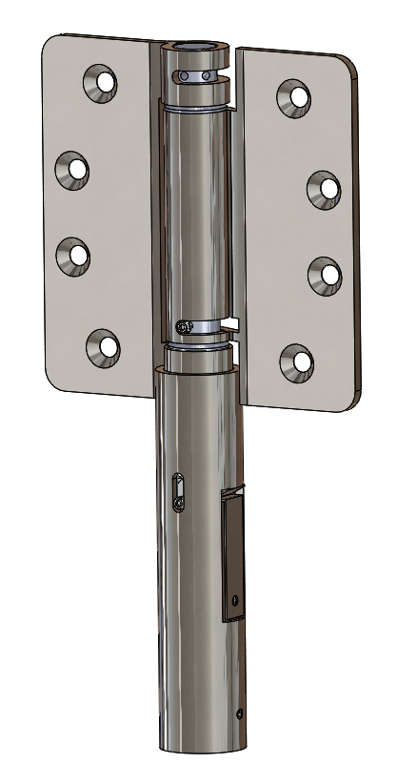 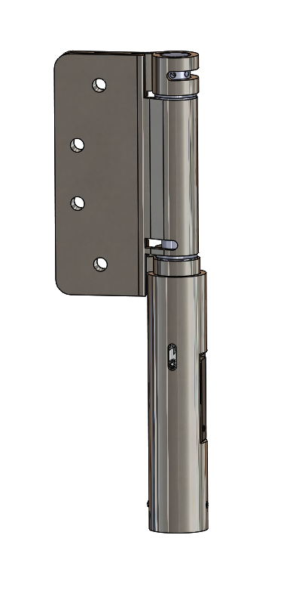

Figure 1: Modified Hinge in Open Position Figure 2: Modified Hinge in Closed Position

### Component Breakdown

Following is the breakdown of the mechanical components of the hinge design

Spring Hinge: The hinge utilized is a Bommer 4300 series spring hinge. Minor modifications were made to the hinge in order to make it work within the design. A slot was added to the center barrel of the hinge to allow the door to swing freely after it has been preloaded with the torque required to close during activation. The lower spring pin was replaced with a custom manufactured shaft to attach the upper gear to the spring.

Ratcheting Gears: A set of contacting gear bodies that allow for clockwise rotation whereas one gear will “float” on the other causing the device to ratchet to its preloaded position and then hold the springs torsion from closing the door until the device is triggered.

Pull Solenoid: Utilized to separate the gear bodies from each other to allow for complete rotation of the upper gear body, ensuring full torsional forces are placed upon the door.

Solenoid Return Spring: During normal preloading ratcheting procedure, this spring will provide the force required to ensure the two gear bodies contact each other during every point in the preloading rotation.

Barrel Extension: Conceals the internals of the hinge components and gives an aesthetic appearance all while keeping the mechanism clear of dust and debris.

Gear Locking Mechanism: Once actuated, the lower gear will be locked into place by a tab of spring steel and allow for the door to act as self closing even if the power were to be cut from the solenoid.

### Prototyping and Testing

In order to fully characterize the hinge that was being modified, we performed testing to find the spring rate of the torsion spring. A socket was attached to the hinge and a torque wrench was used to measure the torque from different levels of angular displacement. We found that there was a linear relationship between torque and angular displacement. From previous hinge testing we knew roughly 300° of angular displacement are necessary to close a standard door. This level of displacement correlates to roughly 28 in-lb of torque.

The initial prototype, seen in Figure 4, met all constraints and was aesthetically appealing, but it was ultimately unsuccessful, because the solenoid was drastically undersized. Frictional forces between the ratcheting gear teeth due to the stored torsional forces were initially unknown, so the solenoid was improperly selected. The initial solenoid, the S-15-75, had a maximum of 2 lb of force which could not separate the gears, even without preload on the hinge. Benchtop testing was performed on this model to measure the force required to separate the gears. A force gauge was attached to the lower gear and used to measure the force necessary to separate the gears given different levels of preload and opening, as seen in Figure 3. The force was also tested for greased and ungreased gears, but it was found that there was no reduction in necessary force with lubrication. This testing revealed that roughly 20 lbs of force was necessary to separate the gears with the level of preload required to close the door. The test data can be found in Appendix C.

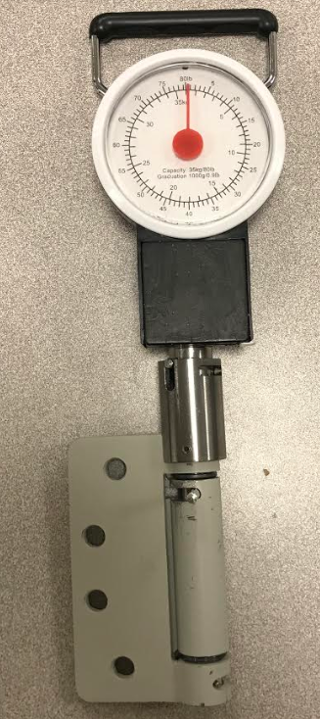 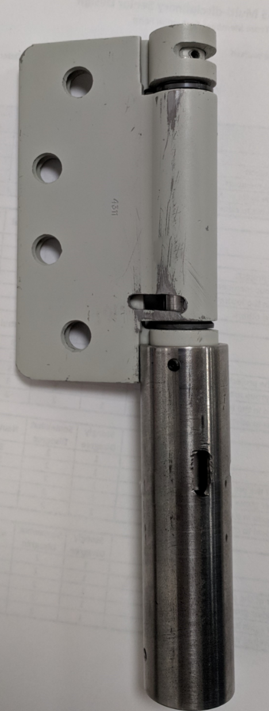

Figure 3: Force Gauge Testing Set Up Figure 4: Fully Assembled Initial Prototype

After the solenoid failed to provide sufficient force to separate the gears, an electromagnet (E-20-100) was chosen to replace the solenoid. The electromagnet supplied a holding force of 45 pounds, which would be sufficient to separate the gears. The electromagnet had a 1” outer diameter, so the barrel extension was cut off to mount the electromagnet, which was held on by a collar. However, the drop off in attractive force over the ⅛” distance between the gear and the electromagnet was not properly accounted for. Ultimately, the attractive force at a distance of 0.125” was not sufficient to separate the gears.

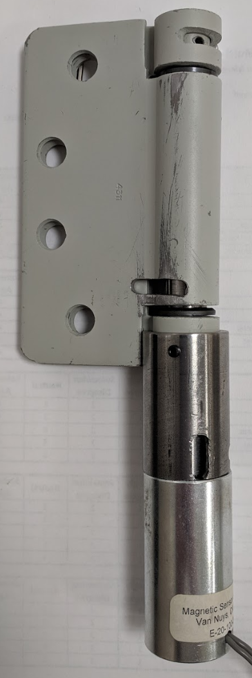

Figure 5: Electromagnet Prototype

After the initial solenoid and electromagnet failed to separate the gears and precise force measurements were taken, a new solenoid (S-29-150) was selected. The solenoid generates over 20 lbs of pulling force with 5400 or 3400 AT, as seen in Figure 6, which is enough to separate the gears. This solenoid has an outside diameter (OD) of 1.5”, which required an overhaul of the design. A new barrel extension was machined in order to attach the solenoid to the hinge and the plunger of the solenoid had to be turned down in order to attach the gears.

In testing, the solenoid was able to trigger at an angular displacement of 142.5𝆩, given 5.5V and 3A. Testing was limited by the power supplies that were available. The internal resistance of the solenoid was 1.3 and the only power supplies available current limited at 3 amps, so we weren’t able to get the maximum voltage from the solenoid.

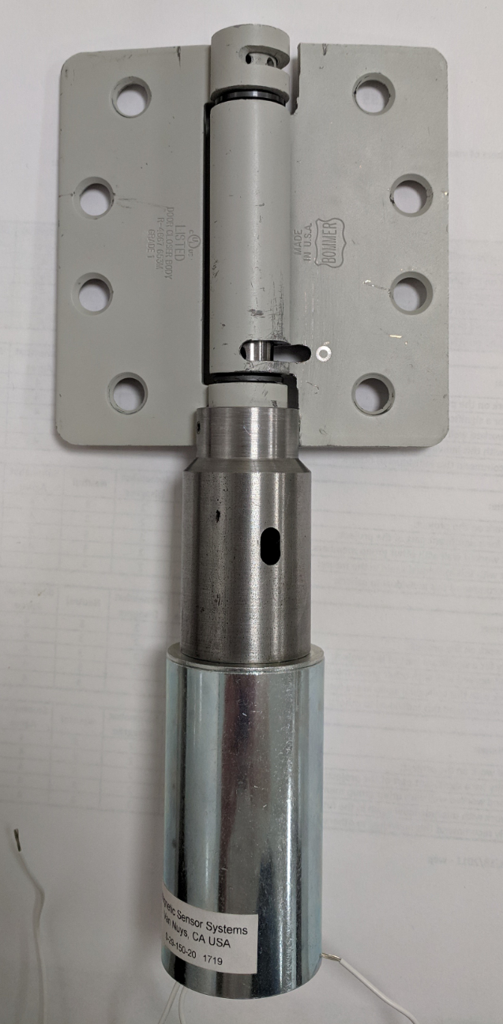 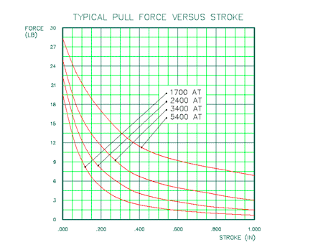

Figure 6: Fully Assembled Final Prototype Figure 7: Data for S-29-150 solenoid

## Electrical

### Summary

The prototyped design of the door hinge utilized Radio Frequency (RF) technology for the control signal and wireless charging capabilities. The design relies on the triggering of a smoke alarm to send an encoded signal that is decoded within the hinge circuitry to trigger the operation of the solenoid. The design also incorporates a wireless power transmitter that provides power through RF that is converted to DC power within the hinge. This passively keeps the batteries at a level that can ensure reliability.

### Component Breakdown

Following is the breakdown of the electrical components of the hinge design

Power Receiver: This design utilized the Powercast P2110B receiver chip. This chip is necessary to harvest power from the Power Cast Transmitter to charge the unit. It is connected to a 915 MHz antenna that receives power in the form of radio frequency waves from the Powercast Powerspot Transmitter.

Power Transmitter: The design utilized the Powercast PowerSpot transmitter. This unit is a consumer product that transmits power wirelessly at 915 MHz to deliver 3W of effective isotropic radiated power. The PowerSpot transmitters follows all FCC and ISED regulations for use in the US as well as Canada.

RF to DC Converter: Used to transmit the received radio signals to usable DC power for the circuit. The RF to DC converter comes onboard the P2110B chip.

Button Batteries: Rechargeable batteries that are to be charged wirelessly to provide power to the circuit and solenoid. The batteries used were four nickel metal hydride button batteries to achieve 4.8 volts.

Voltage Regulator: This component regulates the voltage to a necessary level for the control logic of the circuit. It effectively keeps the voltage of the logic at 5 volts while the battery can operate at up to 9 volts.

Transistor: The transistor is used in the circuit to act as a switch. For this application we used an npn transistor. When the smoke alarm sends the control signal to the hinge the transistor the circuit sends voltage to the base of the transistor enabling it to conduct current across the collector-emitter path. This in turn allows the solenoid operate.

Antennas: We have two sets of antennas in our system. The first antenna is for our power system and recieves power in the form of radio waves at the 915 MHz frequency. The second is for our control system and receives the control signal using the 433 MHz frequency.

RFID Transmitter and Receiver: The RFID transmitter is placed in the smoke alarm. When smoke is detected and the alarm sounds, the control signal is sent to the RFID receiver that is located within the hinge. These RFID chips operate at 433Mhz.

Control Signal Encoder and Decoder: The HT12E and HT12D are encoder and decoder chips that allow for the transfer of the control signal from the RFID transmitter and receiver that then allows the transistor to receive voltage at its base to operate the solenoid.

### Control System

The control system uses a voltage generated in the smoke detector to send a signal wirelessly to the hinge causing it to activate. When the smoke detector is triggered we are able to tap into the 9 volt signal that powers the alarm. From the alarm signal we regulate the voltage from 9 volts to a usable 5 volts for our system. The 5 volts then powers our encoder and RF transmitter and is also sent to an input pin located on the encoder. The encoder has 8 pins located on it labeled A0-A7, these pins are used to create a unique code for our transmitter that needs to be replicated on the decoder. This unique code is used to avoid any interference of devices using the same frequency. Once the signal is encoded it is then sent from one of the four data pins to our RF transmitter input data pin. The transmitter sends the signal using a 433 MHz frequency. This signal can be transmitted up to 100 meters in the open and 20 to 30 meters with obstructions to the receiver.

At the hinge the RF receiver is powered by the 5 volts of the hinge battery. The signal is received from the transmitter and sent from the data pin to an input on the decoder. Here the decoder (using the same unique code as the encoder) will decode and output the signal through its own output data pin. This signal is then sent to one input of an AND gate created by two transistors. The other input to the AND gate comes from the Vt pin of the decoder. The Vt pin is only active when a signal is being received from the transmitter. This AND gate acts as a switch to activate the solenoid. Both the Vt pin and the Data pin need to be active in order for the AND gate to trigger. This means the solenoid will only trigger while the smoke detector is active. Once the solenoid is triggered the batteries will dump all of their power into the solenoid until they are dead or the smoke detector is turned off.

### Power System

The power for the hinge comes from four 1.2 volt Nickel-Metal Hydride batteries. These batteries in series come to a total of 4.8 volts for the system and are rechargeable. They are maintained at a full charge using a wireless RFID charging system. This charging system utilizes the powercast powerspot wireless transmitter. The powerspot transmits power using the 915 MHz band at a distance of up to 12 meters while in line of sight of the hinge. The hinge uses an antenna hooked up to a P2110B receiver chip. This receiver is able to harvest the power in the form of radio waves, rectify the waves, and output at a DC voltage anywhere between 2 and 5.5 volts. This output voltage is set using a resistor between the Vset and Ground. The Vset resistor is chosen using the equation R = 1.21M/(Vout - 3.32). For our design we have the the output set to 5 volts using a 720 kOhm resistor. The P2110B receiver needs an external storage capacitor to provide energy for charging. We used a 100 uF capacitor in our design between the Vcap and Vout. This system will automatically start charging the batteries if the hinge is within the range threshold and the battery voltage is below the specified output.

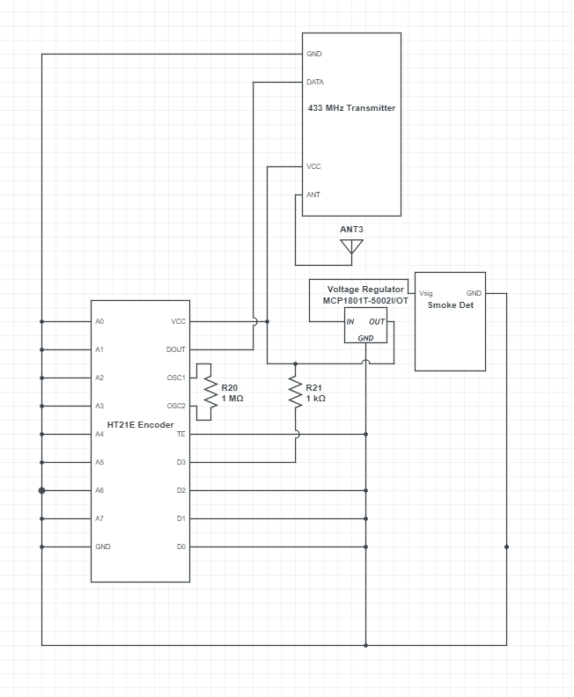

Figure 8: Diagram of the Smoke Detector Transmitter Circuit

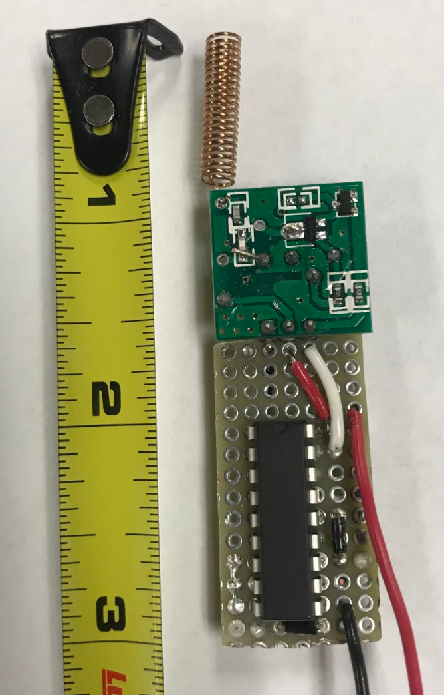

Figure 9: Photo of Smoke Detector Transmitter Circuit

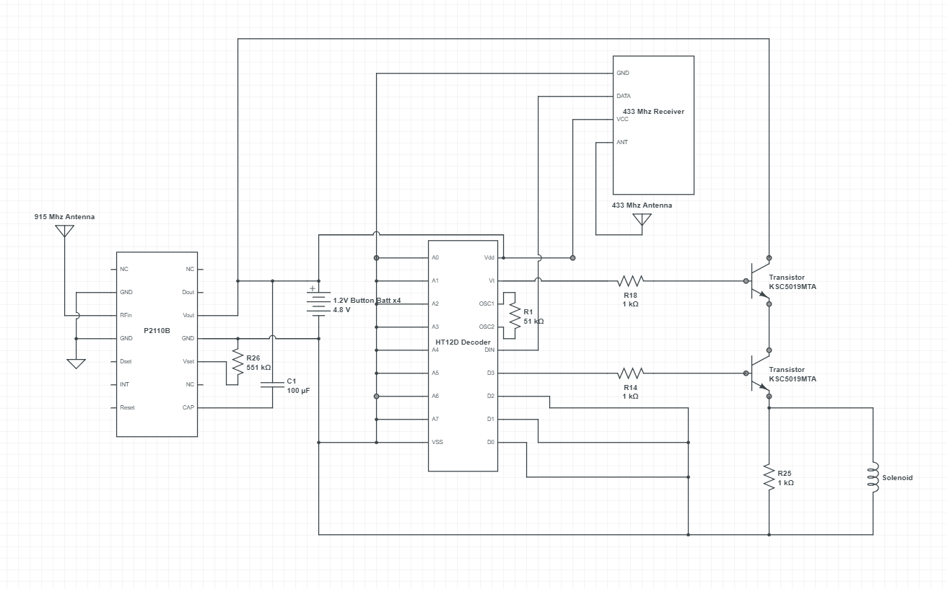

Figure 10: Diagram of the Hinge Receiver Circuit

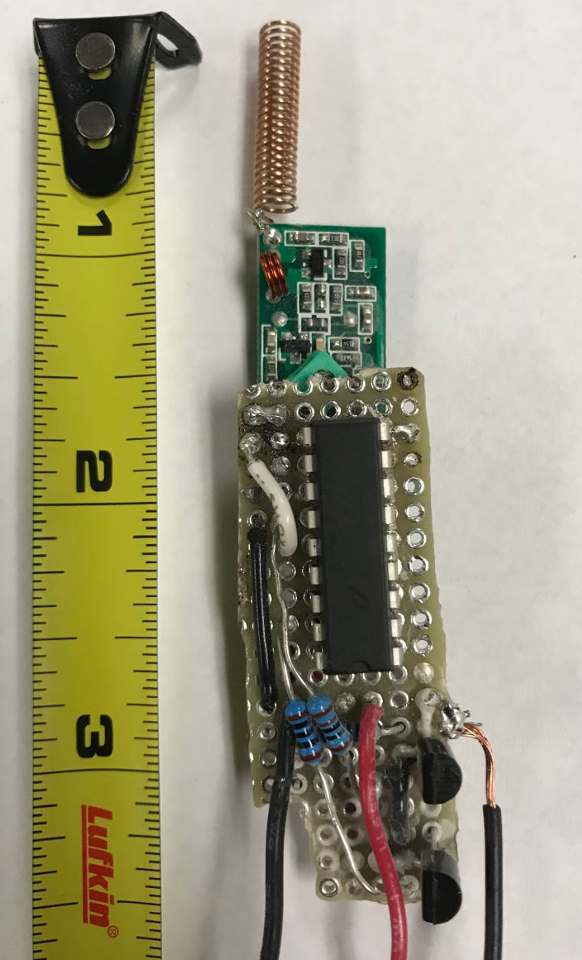

Figure 11: Photo of the Hinge Receiver Circuit

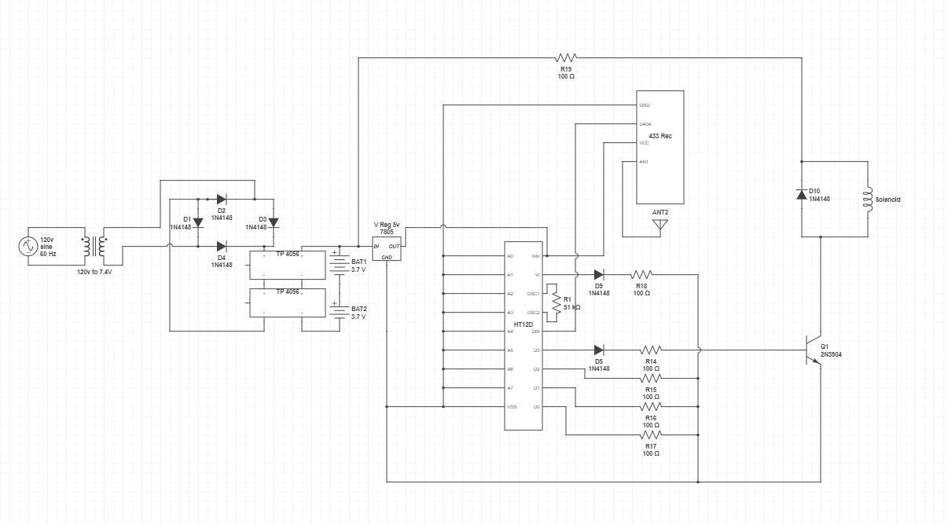

Figure 12: Diagram of the Hardwired Receiver Circuit

### Prototype and Testing

The prototyping phase for the electrical design of the project included two parts. Our design is comprised of a transmitter and receiver circuit. In the final iterations of prototyping the receiver portion was split into two parts itself, those being the triggering mechanism and the other being the wireless recharging with the Powercast. This was done because we were attempting to overcome the friction between the gears and switched to a 9V design. The Powercast is currently not capable of recharging a 9V battery so we created a separate circuit to display the recharging capabilities as a proof of concept.

We first used standard breadboards to prototype our circuits and prove that they operated accordingly. Once this was done we created Eagle files to have a PCB fabricated for our design but the capabilities of doing it in house were no longer available because of the laser table being out of order. The next best option that we found was to use a PTH breadboard that we could solder leads directly to in order to ensure close and secure connections in order to improve reliability as well as efficiency of the overall system. In future iterations of the design we would implement a PCB in order decrease the overall packaging size.

Once we had our transmitter and receiver circuitry on our soldered PTH breadboard we first tested the reliability of our control signal and the distance that we could consistently transmit. After many trials we were able to get a reliable signal at a distance of 100 feet with a direct line of sight between the transmitter and receiver circuitry. This met our expectations since we are using off the shelf parts that may not be exactly ideal due to our available resources. While we were satisfied with our results of our test with no obstructions between the transmitter and receiver we identified that this was not a sufficient test for the application of this design. This design is for use in a residential home and the control signal will have to be able to travel through various different walls and objects. Therefore, we next tested our prototypes through different types of walls. These walls included standard drywall, brick and wood walls. We found that we could guarantee an effective signal between the transmitter and receiver at a distance of 30 feet through all three types of walls. There were instances where we could attain a further distance but 30 feet will provide a distance that we deem very reliable through all standard residential surfaces.

We also ran various tests on the prototype of our wireless charging design. The final prototype was comprised of the P2110B and 915MHZ antenna that recieved the RF power signal from the Powercast PowerSpot transmitter. We were able to measure the voltage that the chip was outputting based on the power it was receiving with a multimeter. We ran many iterations of range tests to measure the reliable charging distance that could be between the receiving circuit and the PowerSpot transmitter. We found that we could maintain a voltage of 5V at a distance of 20 feet. Once we progressed past 20 feet the voltage output from the P2110B chip began to diminish below 5V and was deemed unreliable. But, when keeping it within 20 feet we could provide a slow trickle charge to our 4.8V battery pack which is what was expected and could sustain the battery pack for normal use. An important note to keep in mind is that the Powercast product line is a new and developing technology. With this being the case we learned some very important techniques that must be utilized in a wireless charging design. We found that it is very crucial to ensure antenna orientation was ideal to maximize the output voltage from the P21110B chip. Also, the presence of any object in between the antenna and transmitter drastically decreased the output voltage it was able to provide. These complications that can easily arise with this new technology do not allow us to say that it is a reliable system in its current state. We do believe that in future testing, with the purchase of the industrial Powercast transmitter, a more reliable charging system could be developed with extended range.

We also ran a dBm test on the Powercast signal being sent out from the PowerSpot transmitter. This test was necessary to ensure that FCC standards were being followed. The max dBm that the FCC allows to be transmitted through a signal is 36 dBm. Utilizing the equation P(dBm) = 10 · log10(P(mW)) we were able to attain the dBm of our system. The max value that we measure from our system was 24 dBm which is an equivalent of 1.8 Watts. We got this by testing the voltage of the powercast system where we found an absolute max of 6 volts in all our testing. When measuring the amperage output by our receiver we never reached the max limit of 50 mA but we used this max for our calculations. Calculating P(dBm) = 10 · log10(6V·50mA) we got our 24 dBm value. This was well below the threshold required by the FCC because a value of 36 dBm is the equivalent of 4 Watts. These results allow us to confirm that the FCC regulations were adhered to in our design.

At the conclusion of our tests we came to the consensus that given the power available from our batteries and the amount of mechanical friction that need be overcome when attempting to separate the gears, a hardwired system would be a more practical approach. Our concept of a hardwired design can be seen above in figure 12. This system would still operate at 9V so it would not be violating any codes but it would be able to provide the adequate amount of power necessary to allow the hinge to operate as designed.

### Concepts Explored

This section will describe some of the various concepts that we considered throughout the design process but that were not implemented in our final design. Some of these concepts we found would not work with our design but could be considered in future designs.

For the wireless charging of the batteries we came up with various concepts early in our design process. The first concept was wireless charging using a wifi signal. Wifi signals use the 2.4 and 5 Ghz bands unlike lower frequency chargers. These bands are referred to as “bursty” and somewhat inconsistent since they are so dependent on traffic patterns and a somewhat steady amount of RF energy is placed in the many slot frequencies it hops. Another concept that we explored was the use of piezoelectric technology. We looked into if the door would have enough force when closed to generate a voltage high enough to charge our batteries over time. We did some testing and found that we only generated a voltage spike of .7 volts that lasted only a couple seconds before dissipating. When considering companies that had premade wireless charging technology we looked into a company called Wi-Charge. Wi-Charge used infrared light to send energy wirelessly to desired application. We got in contact with the company to explore options with their beta program since they had yet to release a commercial product. Unfortunately they had too many companies wanting to develop products using their technology and had to turn our application down. In the future when their technology is more established they could be another option to rival the powercast systems in wireless charging.

There were also various different power storage devices considered for the hinge design. We first looked at the possibility of utilizing a super capacitor but after looking more into them the conclusion was made that for the size parameters of the design a super capacitor would not be ideal. We identified using button cell batteries in series to be the ideal power source for our applications since they could easily be packaged within the barrel of the hinge. We purchased a few different batteries including 3.7 Li-ion batteries as well as 1.2V NiMH. After more research we found that with the capabilities of the Powercast technology four NiMH batteries in series with a voltage of 4.8V could be trickle charged but two Li-ion in series with a voltage of 7.4V was not compatible. Future attempts may want to consider a design where batteries can be replaced much like those in a smoke alarm. This is recommended since the Li-ion pack produced more pull force with the chosen solenoid but was not compatible to be recharged.

One feature we wanted to implement into our design was a battery charge indicator. For this design we looked into using a LM324 op amp with four LEDs representing 100%, 75%, 50%, and 25%. To accomplish this we would use each of the four op amps in the LM324 chip as a comparator with its own reference voltage. We would use a combination of resistors to create a voltage divider that sets a unique reference voltage for each comparator corresponding to our percentage values. And each comparator would be attached to an LED indicator, the colors of the LEDs would be red, orange, yellow, and green to represent the voltages from 0 to 100%. We omitted this portion of the design in our final prototype due to limits on space within the hinge. Having this circuit would have added another inch to two inches in our final design but could still be utilized in future designs if allotted more space.

# Cost Analysis

Smoke Shield was not given a firm budget at the start of this project but the goal was to keep the budget under 1,000 dollars. Pricing for the mechanical and electrical components of the project are broken down below. Table 1 shows the cost breakdown down for mechanical components and materials for the final prototype. Table 2 breaks down the costs for components of the electrical system.

## Bill of Materials

Table 1: Mechanical System Breakdown

| **Vertical Ratchet System** | | | | |
| --- | --- | --- | --- | --- |
| **Parts:** | **Vendor:** | **Quantity:** | **Unit Cost:** | **Total Cost:** |
| **Pull Solenoid, S-29-150** | Electromechanics Online | 1 ea | $122.03 | $122.03 |
| **Self Closing Door Hinge** | McMaster Carr | 1 ea | $17.33 | $17.33 |
| **Machined Ratcheting Gears** | University of Minnesota Duluth | 2 ea | $71.74 | $71.74 |
| **1 ¼” Low Carbon Steel Rod- 1 ft length** | McMaster Carr | 1 ea | $4.28 | $20.55 |
| **½” Low Carbon Steel Rod- 1 ft length** | McMaster Carr | 1 ea | $0.61 | $3.66 |
| **Solenoid Return Spring** | Electromechanics Online | 1 ea | $2.36 | $2.36 |
| **6-32 X 3/16” Cup Point Set Screw** | McMaster Carr | 2 ea | $0.22 | $10.90 |
| **6-32 X ½” Set Screw** | McMaster Carr | 1 ea | $0.13 | $13.23 |
| **5/32” Groove Pin- 1” Long** | McMaster Carr | 1 ea | $0.50 | $12.42 |
| **Total:** |  | | $219.20 | $273.21 |

Table 2: Electrical System Breakdown

| **Parts** | **Vendor** | **Quantity** | **Cost** |
| --- | --- | --- | --- |
| **Power Transmitter** | NextWareHouse | 1 per home | $136.64 |
| **Power Receiver** | DigiKey | 1ea | $44.40 |
| **RF to DC Converter** | DigiKey | 1ea | $2.81 |
| **Button Batteries** | DigiKey | 2 ea | $22.30 |
| **Voltage Regulator** | DigiKey | 2 ea | $0.43 |
| **Transistor** | DigiKey | 2 ea | $0.45 |
| **Solenoids** | Solenoid City | 1 ea | $41.14 |
| **Resistor** | University of Minnesota Duluth | 1 ea | $0.50 |
| **Logic Chip** | Amazon | 1 ea | $9.99 |
| **RFID Transmitter & Receiver** | Amazon | 1 ea | $10.55 |
| **Antennas** | Mouser Electronics | 1 ea | $3.26 |
| **Total:** |  | | $272.47 |

## Cost Breakdown for Large Scale Manufacturing

The first step to analyze the manufacturing of the hinge is to produce on a supply and demand scale. Manufacturing of the hinge to meet customer demand would initially would be contracted out to a facility, because financially there isn’t a substantial enough market to justify getting a loan and establishing a manufacturing facility. Once sufficient profits are generated and a reliable demand of at least 200 hinges per day is present, a manufacturing facility will need to be constructed to meet customer demand and produce a higher volume of hinges, also licensing will need to be generated to increase profits becoming self sustaining.

Below, is a comparison of starting a facility in Minnesota versus California, profits and loan amounts for a 15 year and 30 year mortgage are presented with profit values over a 35 year period. All expenses are included in the initial loan amount, for example; salaries, number of workers, initial supplies, tooling, contractor work, cost breakdown of the parts, etc. can be seen in Appendix F.

Based on overall costs to manufacture for the product to have a desirable profit margin per unit the demand needed to be at 200 units per day. Acknowledging the cycle time per unit is not optimal, outside contracting or two assembly lines may be necessary to meet that target while implementing manufacturing techniques like six sigma and lean manufacturing.

Table 3: General manufacturing information used to calculate profits based on production.

| **Demand Per Day** | **Operating time** | **Demand Per Hour** | **Cycle time per Unit** |
| --- | --- | --- | --- |
| 200 | 14.5 hours | 13.793 | 4.35 minutes |

Using the above information from table ____. The profit margin per unit (Table ____) is analyzed at a variety of different costs to the customer (stores) before taxes. Establishing pricing, the main competitors (LifeDoor) price of $109 for a single unit, were taken into consideration. Along with a desirable profit margin to financially make sense and be profitable. LifeDoor is an object on your door, and is obvious that it’s there, where Smoke Shields hinge is non-obvious and fits in your traditional door. That’s where the price of the Smoke Shield hinge could be considerably larger. After that was concluded, a desirable price for the customer, while collecting a sufficient profit, to be competitive in the market would be $210. Market studies will be done to see the extra price people would pay for a product that was non-obvious in their homes.

Table 4: The Profits per unit after labor cost and material cost and before taxes. The profit margin per unit is ran at multiple costs.

| **Profit Margin Per Unit Based on Customer Cost** | | |
| --- | --- | --- |
| **Price Per Unit** | **Minnesota** | **California** |
| $250 | 57.88% | 58.53% |
| $240 | 51.57% | 52.19% |
| $230 | 45.25% | 45.85% |
| $220 | 38.94% | 39.51% |
| $210 | 32.62% | 33.17% |
| $200 | 26.30% | 26.83% |
| $190 | 19.99% | 20.48% |
| $180 | 13.67% | 14.14% |
| $170 | 7.36% | 7.80% |

The profits can be seen below in table 5. At a cost of $210 dollars per unit. After taxes and all other expenses (Labor cost, material cost, maintenance, interest rates, etc.) for manufacturing the product out of a single facility with a lifespan of 35 years. The yearly profits can be seen in Figure 13.

Table 5: Total Profits after 35 years of manufacturing with a consistent demand based on different mortgage lengths in Minnesota and California.

| **Total Profits Analyzed at 35 years of Manufacturing** | | |
| --- | --- | --- |
| **Mortgage Lengths** | **Profits Minnesota** | **Profits California** |
| **15 Years** | $42,428,016.72 | $38,149,036.09 |
| **30 Years** | $40,958,797.86 | $38,082,656.70 |

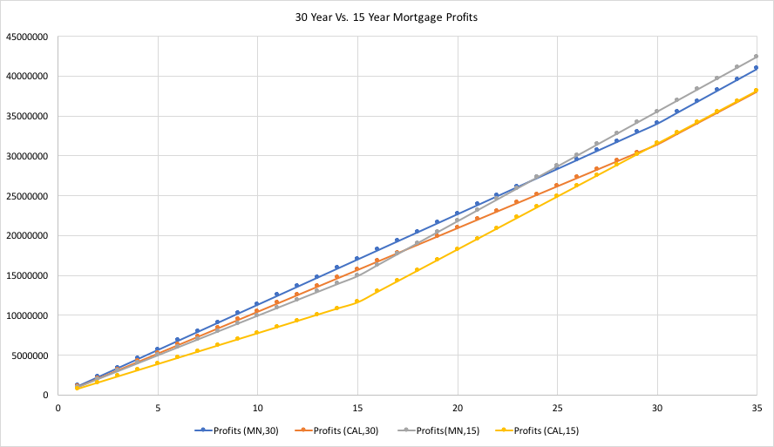Figure 13: Profit Projections given 15 or 30 year loan terms on facilities in MN or CA. The most profitable manufacturing facility is in Minnesota with a 15 year mortgage.

# Future Recommendations

The final prototype was ultimately successful, but there are ways to improve the functionality and appearance of the hinge. We recommend investigating the production of a custom solenoid that can provide sufficient pulling force with a smaller barrel diameter and length. We also recommend further investigation of the ratcheting gear design, including optimizing the number of teeth, finding a gear pitch that minimizes friction while securely holding the torsion of the spring and looking into materials and coatings that can minimize the frictional forces on the gear teeth. The use of a linear actuator in place of the solenoid could also be explored if a sufficiently small and powerful solenoid can not be found.

Smoke Shield also recommends that the design of the barrel extension and slotting systems are updated to fully enclose the internal mechanisms of the hinge. Production of a custom manufactured multi-layered printed circuit board is also recommended, to make the electronics fully enclosed. This will ensure that no dust or debris can enter the system making the device compliant with fire code requirements and extending the longevity of the device. Other wireless charging transmitters such as the powercast TX91501 and the Wi-Charge system may offer more reliable and sufficient charging methods. Before manufacturing, we recommend extensive reliability and lifecycle testing of the prototype.

Furthermore, Smoke Shield recommends creating a user friendly phone app and center console that will allow the homeowner to monitor the battery life and connectivity status of the hinge. Additionally, the phone app and center console could remind the owner of maintenance and routine testing to maintain compliance with fire codes. Further improvements to the hinge could include sensing whether doors are open or closed and relaying that information to the system through the use of microcontrollers. Another application of the phone app would be to trigger all the doors to shut, so one can routinely check the system without having to set off a smoke detector.

After the system is optimized we recommend extensive testing that makes the product compliant with the fire codes detailed in Appendix D. Test Protocols have already been generated in Appendix E if those are followed the product should be compliant with the fire codes.

# Summary & Conclusion

Smoke Shield was tasked with designing, prototyping and testing a self closing door hinge to automatically close a door in the event of a fire. The chosen design utilized a pre-manufactured spring hinge that was modified with a vertically ratcheting gear system. The vertical ratcheting gears were enclosed in a barrel extension that also housed a solenoid to separate the gears and a flat spring to lock the lower gear in place after triggering. The fundamentals of the design proved to be successful, but the initial solenoid was undersized. Force testing demonstrated that the hinge required roughly 20 lbs of pull force to overcome the friction between the gears. A tubular electromagnet was then utilized in order to provide the required force, however, it didn’t have enough pull force to overcome the distance to the lower gear. After the electromagnet failed a new solenoid was selected and the barrel extension was redesigned. The chosen solenoid was rated to provide 28 lbs of force with 5400 AT and was found to be successful at triggering the hinge device.

This is a problem that Chief Cooper and Professor Carrillo have been grappling with for years. Currently there is no resettable, low profile design on the market to solve this problem. The final prototype ultimately proved that a sufficiently strong and powered solenoid can separate the gear bodies and trigger the hinge. We also demonstrated effective wireless charging and triggering systems for the device. There is work to be done on the device, but we have moved the project forwards.

# References

BHMA Standards. (n.d.). Retrieved from <https://www.buildershardware.com/bhma-standards/ansibhma-a1561-butts-and-hinges>

LifeDoor. (n.d.). Retrieved from <https://www.lifedoor.io/>

McMaster-Carr. (n.d.). Retrieved from <https://www.mcmaster.com/>

CeaseFire (n.d.). Retrieved from <http://ceasefiredoorhinge.com/>

Temperature-Activated Hinge Could Shut Doors (n.d.). Retrieved from <https://boston.cbslocal.com/2018/05/28/cease-fire-door-hinge-fire-safety-video-wbz-tv/>

PowerCast (n.d.). Retrieved from [http://www.powercastco.com](https://www.powercastco.com)/

Wi-Charge (n.d.). Retrieved from <http://www.wi-charge.com/>

International Code Council. (2014). International Fire Code 2015.

2016 California Fire Code: California Code of Regulations, Title 24. (n.d.).

# Appendices

## Appendix A: Disassembly Instructions

1. Open hinge 180° and orient with the bottom roll pin facing upwards.

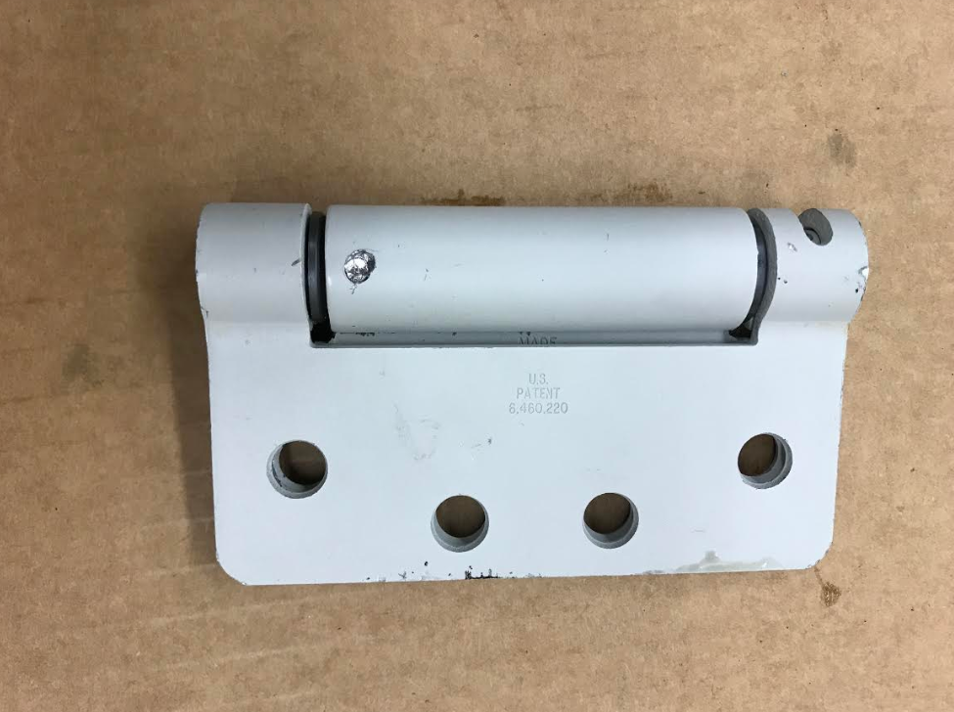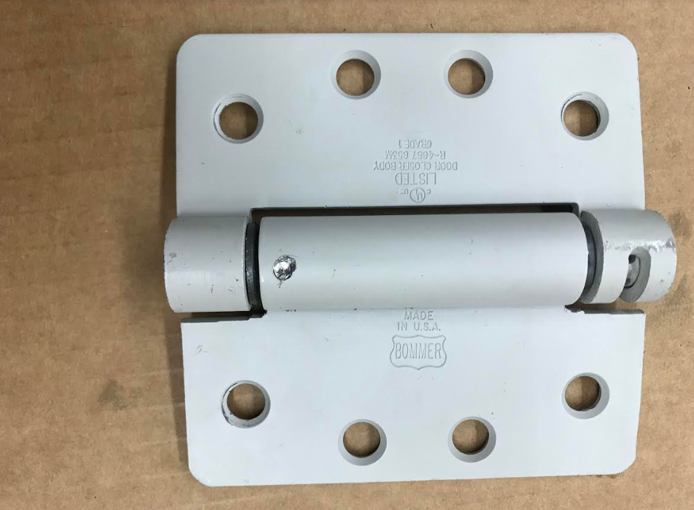

2. Take a center-punch to the very center of the roll pin and make a deep enough groove to ensure a drill will cut away all of the pin without damaging the housing of the hinge. Use 1/32” drill bit and drill ½“ deep, change to a 3/16” bit and drill the ½“ distance down. Clean the hole to ensure there is no material blocking the hole from allowing the bottom pin to be knocked through and out of the housing.

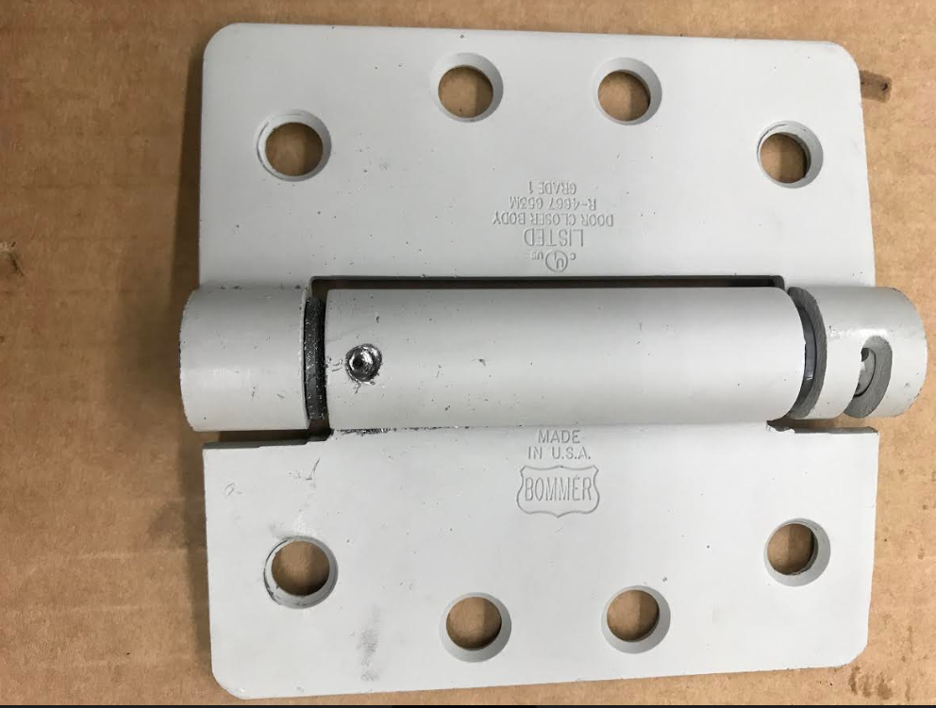

3. Use a solid punch to knock the spring and pins assembly from the bottom up and then fully remove the internal components of the hinge.

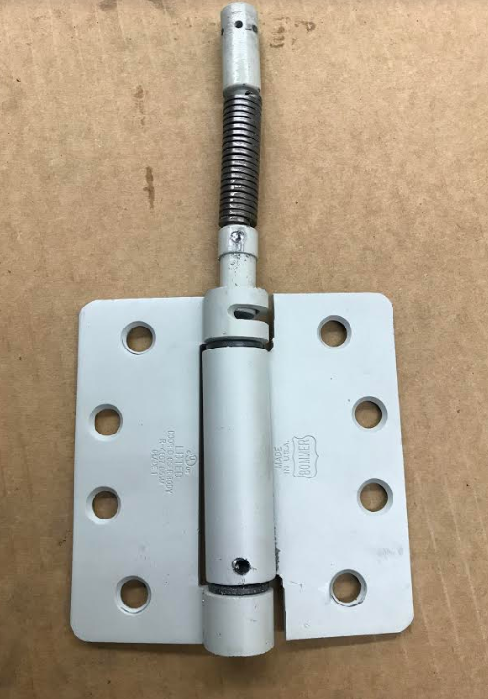

4. Separate the two hinge plates from alignment and then remove the plastic bushings from the hinge plates.

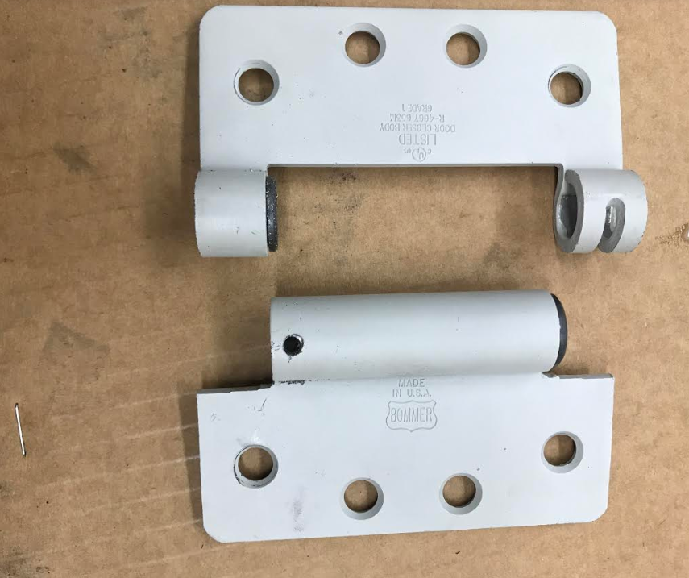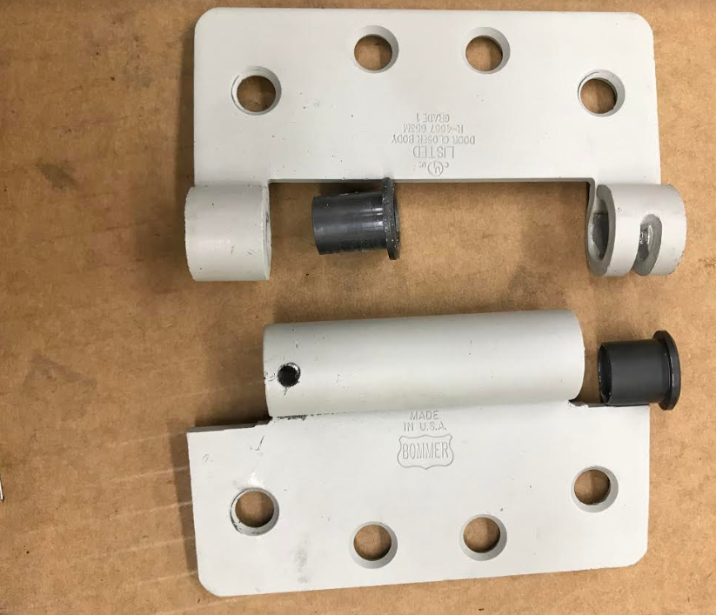

5. Using a pry bar or standard screwdriver, pry up on the spring to separate the spring from the lower centering pin.

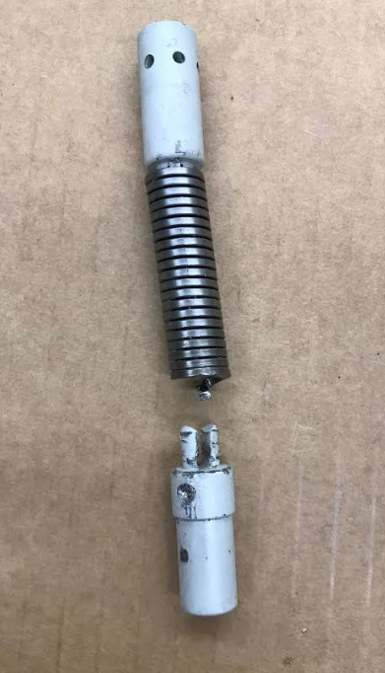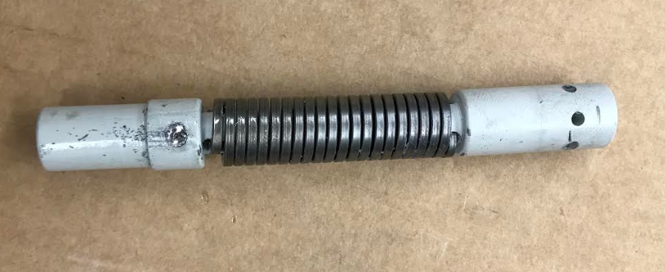

6. Fully disassembled hinge.

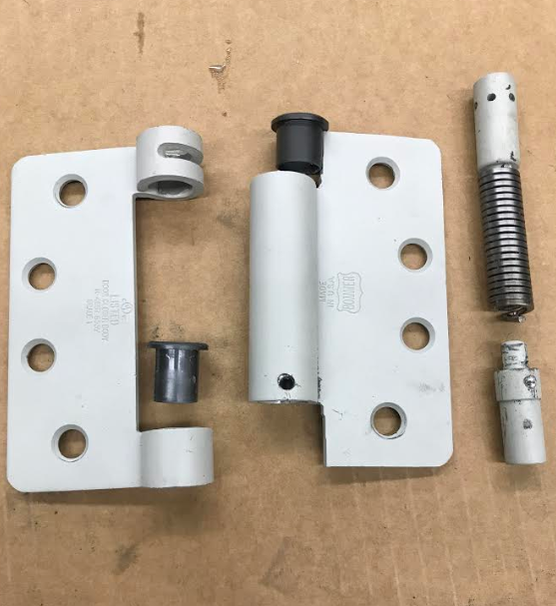

## 

## Appendix B: Assembly Instructions

1. Align machined lower spring pin with lower spring side. Press spring into lower spring pin.

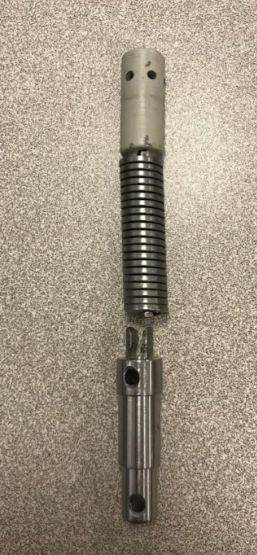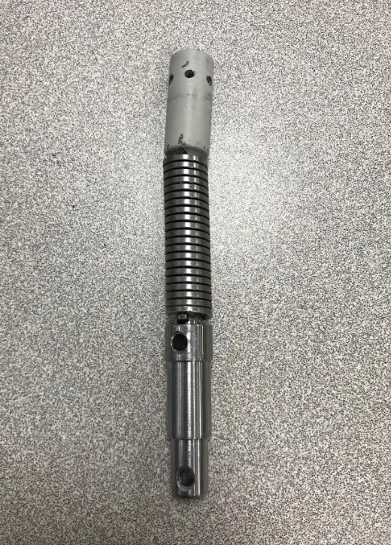

1. Align spring pin assembly with hinge assembly.

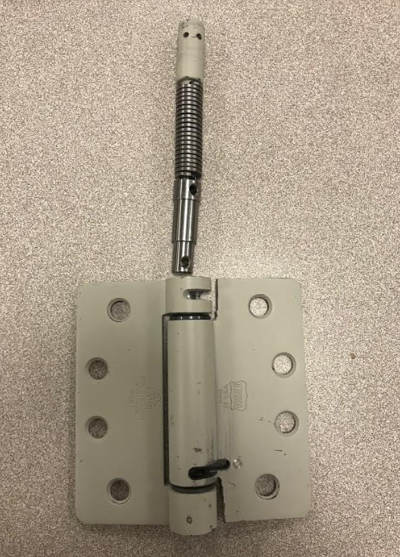

1. Press spring pin assembly into hinge assembly and align pin holes.

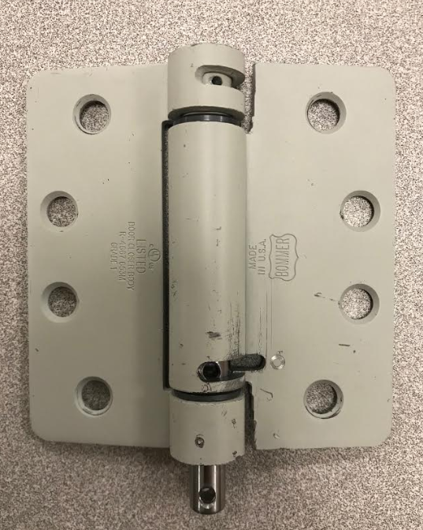

1. Insert roll pin and top load pins with zero preload (For ease of installation).

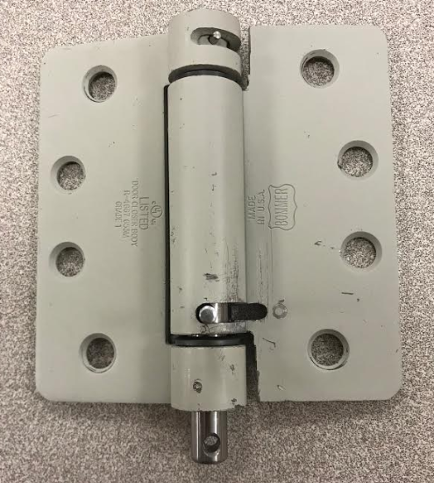

1. Place top gear body onto shaft, insert set screw to lock into place.

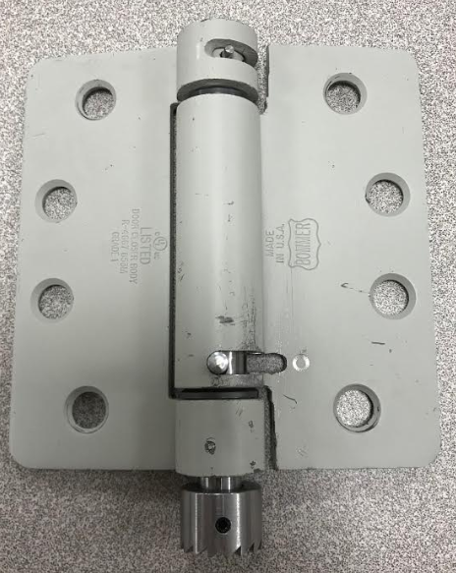

1. Assemble barrel extension by inserting solenoid into bottom end, bottom gear into top end, and inserting roll pin connecting the solenoid shaft and the gear into alignment with the slotting on the barrel extension.

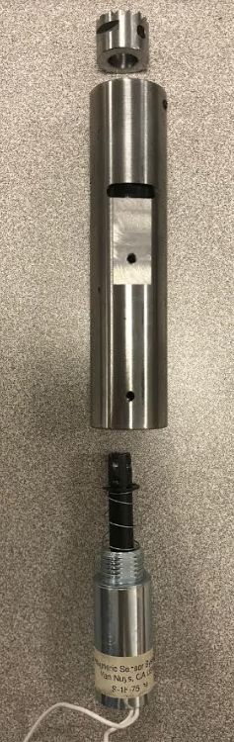

1. Slide barrel extension onto the hinge assembly, tighten set screws to complete installation.

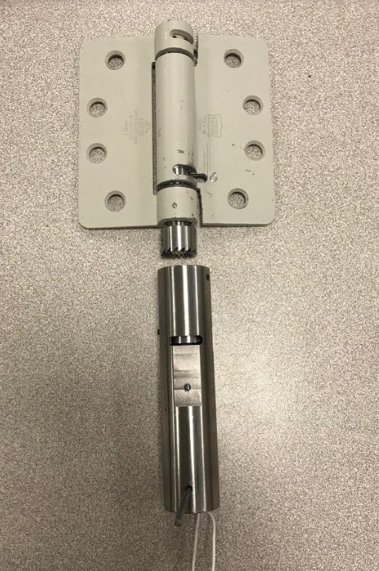

1. Finished assembly with zero preload, install hinge on door and preload.

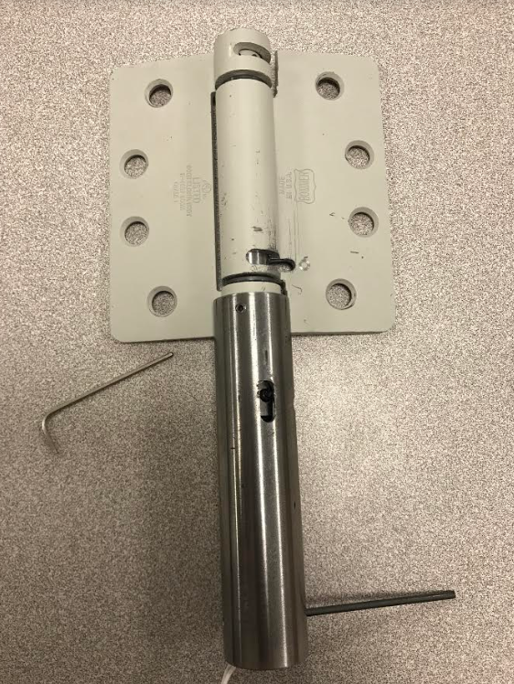

## Appendix C: Test Results

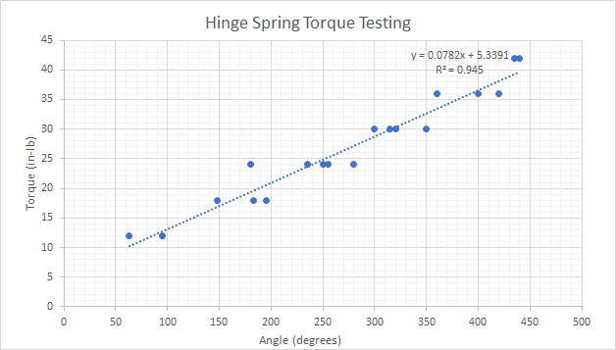

Hinge Spring Torque Testing

Hinge Spring Testing Data

| **Angle (degrees)** | 63 | 148 | 180 | 95 | 195 | 255 | 183 | 235 | 300 | 250 | 315 | 360 | 280 | 320 | 420 | 435 | 350 | 400 | 440 |
| --- | --- | --- | --- | --- | --- | --- | --- | --- | --- | --- | --- | --- | --- | --- | --- | --- | --- | --- | --- |
| **Torque (in-lb)** | 12 | 18 | 24 | 12 | 18 | 24 | 18 | 24 | 30 | 24 | 30 | 36 | 24 | 30 | 36 | 42 | 30 | 36 | 42 |

Gear Testing with and without lubrication

|  | 1 preload | 2 preload | 3 preload |
| --- | --- | --- | --- |
| Ungreased | 7 lbs (2 ratchets) | 12 (2 ratchets) | 14 (1 ratchet) |
| Greased | 7 lbs (2 ratchets) | 12 (2 ratchets) | 14.5 (1 ratchet)  18 (2 ratchet) |

Gear Force Testing for Solenoid Pull

| Preload | Ratchet | Angle (degrees) | Force (lbs) |
| --- | --- | --- | --- |
| 0 | 2 | 45 | 2 |
| 1 | 2 | 105 | 6 |
| 2 | 2 | 165 | 12 |
| 3 | 2 | 225 | 15 |
| 4 | 2 | 285 | 17 |

### 

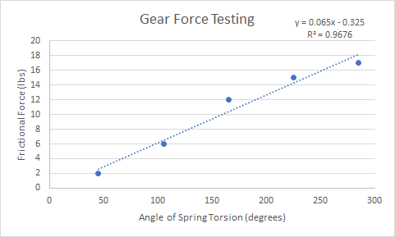

Figure 14: Gear Force Testing

## 

## Appendix D: IFC & California Fire Codes

Below is the fire codes we used in the process of becoming compliant and certified. Underneath each code has a comment on why it was relevant.

* **IFC Chapter 6 Fire Codes: Building Services and Systems**
  + **604.2.15 Smoke Control Systems:** Standby power shall be provided for smoke control systems as required in Section 909.11.
    - Demonstrate design feature- if we want to be a smoke control system
  + **604.5 Operational inspection and testing:**  Emergency power systems, including all appurtenant components, shall be inspected and tested under load in accordance with NFPA 110 and NFPA 111.
    - We need to prove that our system under the specified load (weight of the door) will operate appropriately.
  + **604.7 Supervision of maintenance and testing:** Routine maintenance, inspection and operational testing shall be overseen by a properly instructed individual.
    - Provide testing log to user. Also to comply with this code we will need to generate a maintenance schedule. Even an alert system when the product is malfunctioning.
  + **605.8 Electrical motors:** Electrical motors shall be maintained free from excessive accumulations of oil, dirt, waste and debris.
    - Demonstrate design (solenoid encasement), user maintenance log.
* **IFC Chapter 7 Fire Codes: Fire and Smoke Protection Features**
  + **703.1.2 Smoke barriers and smoke partitions:** Required smoke barriers and smoke partitions shall be maintained to prevent the passage of smoke. Openings protected with approved smoke barrier doors or smoke dampers shall be maintained in accordance with NFPA 105.
    - Applies to door on which hinge is mounted.
  + **703.2.2 Hold-open devices and closers:** Hold-open devices and automatic door closers, where provided, shall be maintained. During the period that such device is out of service for repairs, the door it operates shall remain in the closed position.
    - Provide maintenance log & user manual
    - The hinge would be placed under the closers portions of this code. It must be stated in our manual that when the hinge is in maintenance the door must be remained closed. This is for Industrial purposes.
  + **703.2.3 Door operation:** Swinging fire doors shall close from the full-open position and latch automatically. The door closer shall exert enough force to close and latch the door from any partially open position.
    - Requires testing to demonstrate door can be latched from any position
    - The hinge must be able to fully latch the door at any angle at which the door is open to be in accordance with this fire code.
* **IFC Chapter 9 Fire Codes: Fire Protection Systems**
  + **901.2 Construction documents:** The fire code official shall have the authority to require construction documents and calculations for all fire protection systems and to require permits be issued for the installation, rehabilitation or modification of any fire protection system. Construction documents for fire protection systems shall be submitted for review and approval prior to system installation.
    - Provide documentation
    - We will need to provide calculations proving the door will shut not just proving it through actually showing it.
  + **901.4.5 Appearance of equipment:** Any device that has the physical appearance of life safety or fire protection equipment but that does not perform that life safety or fire protection function shall be prohibited.
    - Demonstrate design features- prove it performs function
  + **907.2.11.5 Interconnection:**Where more than one smoke alarm is required to be installed within an individual dwelling unit or sleeping unit in Group R or I-1 occupancies, the smoke alarms shall be interconnected in such a manner that the activation of one alarm will activate all of the alarms in the individual unit. Physical interconnection of smoke alarms shall not be required where listed wireless alarms are installed and all alarms sound upon activation of one alarm. The alarm shall be clearly audible in all bedrooms over background noise levels with all intervening doors closed.
    - Demonstrate design feature
    - Although we aren’t a smoke alarm I can imagine we will have the same requirement for interconnection, we should be able to pass this code with our RFID technology and the transmitters.
  + **907.2.11.6 Power source:** In new construction, required smoke alarms shall receive their primary power from the building wiring where such wiring is served from a commercial source and shall be equipped with a battery backup.
    - Demonstrate design feature- hardwire option
    - The Hinge isn’t a smoke alarm but I believe we might need to hardwire our RFID’s power source into the buildings primary power.
  + **909.3 Special inspection and test requirements:** In addition to the ordinary inspection and test requirements that buildings, structures and parts thereof are required to undergo, smoke control systems subject to the provisions of Section 909 shall undergo special inspections and tests sufficient to verify the proper commissioning of the smoke control design in its final installed condition. The design submission accompanying the construction documents shall clearly detail procedures and methods to be used and the items subject to such inspections and tests.
    - Provide inspection info/log
    - We will have to have some sort of verification company after the product is installed in houses.
  + **909.4.6 Duration of operation:** All portions of active or engineered smoke control systems shall be capable of continued operation after detection of the fire event for a period of not less than either 20 minutes or 1.5 times the calculated egress time, whichever is greater.
    - Demonstrate design feature- locking gear
    - Our locking mechanism for the solenoid should help us pass this code.
  + **909.6 Pressurization method:** The primary mechanical means of controlling smoke shall be by pressure differences across smoke barriers. Maintenance of a tenable environment is not required in the smoke-control zone of fire origin.
    - Testing required
    - Is there a pressure difference across the doors?
  + **909.12.1 Verification:** Control systems for mechanical smoke control systems shall include provisions for verification. Verification shall include positive confirmation of actuation, testing, manual override and the presence of power downstream of all disconnects. A preprogrammed weekly test sequence shall report abnormal conditions audibly, visually and by printed report. The preprogrammed weekly test shall operate all devices, equipment, and components used for smoke control.
    - Would need to create a test sequence and demonstrate design feature
    - In our manual we need to have a checklist for verification that everything is working.
  + **909.12.2 Wiring:** In addition to meeting requirements of NFPA 70, all wiring, regardless of voltage, shall be fully enclosed within continuous raceways.
    - Demonstrate design feature
    - The wiring in our system needs to be fully enclosed. The only thing that might give us trouble would be the antenna from what I understand however, it shouldn’t be an issue.
* **California Chapter 5 Fire Codes: Fire Service Features**
  + **510.1 Emergency responder radio coverage in new buildings:** All new buildings shall have approved radio coverage for emergency responders within the building based upon the existing coverage levels of the public safety communication systems of the jurisdiction at the exterior of the building.
    - Would need to demonstrate design feature
    - Will our RFID technology have any interference with emergency responder radio coverage.
* **California Chapter 6 Fire Codes: Building Services and Systems**
  + **604.6 Emergency lighting equipment:**Emergency lighting shall be inspected and tested in accordance with Sections 604.6.1 through 604.6.2.1.
    - This code is included just in case we decide to incorporate an LED light on the product to illuminate when activated. In this case we would then have an emergency lighting equipment.
  + **604.6.1 Activation test:** An activation test of the emergency lighting equipment shall be completed monthly. The activation test shall ensure the emergency lighting activates automatically upon normal electrical disconnect and stays sufficiently illuminated for not less than 30 seconds.
    - If we incorporate the light we need to put in the manuals record sheet a activation test to make sure the light works monthly. I believe this is more for industrial purpose than residential.
  + **604.6.1.1 Activation test record:** Records of tests shall be maintained. The record shall include the location of the emergency lighting tested, whether the unit passed or failed, the date of the test and the person completing the test.
    - Again in the manual needs to be a area this can be recorded if we incorporate an LED
  + **604.6.2 Power test:** For battery-powered emergency lighting, a power test of the emergency lighting equipment shall be completed annually. The power test shall operate the emergency lighting for not less than 90 minutes and shall remain sufficiently illuminated for the duration of the test.
    - If our LED is to be powered by the batteries the LED needs to be able to be sufficiently lit for 90 minutes.
  + **604.6.2.1 Power test record:** Records of tests shall be maintained. The record shall include the location of the emergency lighting tested, whether the unit passed or failed, the date of the test and the person completing the test.
    - Again in the manual we need a place to record this with the included information: location, pass or fail, date, and person completing the test.
  + **605.8 Electrical motors:** Electrical motors shall be maintained free from excessive accumulations of oil, dirt, waste and debris.
    - We need to make sure our pull solenoid is free of debris, a way to test this is to possibly put the product in a container and blast it with debris for x amount of time to study the collection.
* **California Chapter 7 Fire Codes: Fire and Smoke Protection Systems**
  + **703.2.2 Hold-open devices and closers:** Hold-open devices and automatic door closers, where provided, shall be maintained. During the period that such device is out of service for repairs, the door it operates shall remain in the closed position.
    - This is more Industrial than Residential and this is more on the user than ourselves.
  + **703.2.3 Door operation:** Swinging fire doors shall close from the full-open position and latch automatically. The door closer shall exert enough force to close and latch the door from any partially open position.
    - Through a series of tests we can prove our door can latch automatically from any position. A calculation is provided in the fire code 909.6.2 in the IFC fire codes. We will need proof of theoretical and actual proof.
* **California Chapter 9 Fire Codes: Fire Protection Systems**
  + **901.2 Construction documents:** The fire code official shall have the authority to require construction documents and calculations for all fire protection systems and to require permits be issued for the installation, rehabilitation or modification of any fire protection system. Construction documents for fire protection systems shall be submitted for review and approval prior to system installation.
    - As discussed in IFC fire code 901.2 we need to supply construction documents with full calculations to prove the system works.
  + **901.4.5 Appearance of equipment:** Any device that has the physical appearance of life safety or fire protection equipment but that does not perform that life safety or fire protection function shall be prohibited.
    - We shouldn’t have to worry about this too much because a hinge doesn’t have the physical appearance of a life safety or fire protection equipment. However, the odd chance they say it does our system works so not an issue.
  + **907.2.11.5 Interconnection:** Where more than one smoke alarm is required to be installed within an individual dwelling unit or sleeping unit in Group R occupancies, the smoke alarms shall be interconnected in such a manner that the activation of one alarm will activate all of the alarms in the individual unit. Physical interconnection of smoke alarms shall not be required where listed wireless alarms are installed and all alarms sound upon activation of one alarm. The alarm shall be clearly audible in all bedrooms over background noise levels with all intervening doors closed**.**
    - We aren’t a smoke alarm but it is very easy to see how this code would be edited to incorporate our device. I'm assuming that there will be an edit we need to be able to make sure one activates the others.
  + **909.4.1 Stack effect:** The system shall be designed such that the maximum probable normal or reverse stack effect will not adversely interfere with the system’s capabilities. In determining the maximum probable stack effect, altitude, elevation, weather history and interior temperatures shall be used.
    - Will elements described above in anyway affect how our system operates, if so how, what needs to be adjusted, and theoretically we need to calculate how we can adjust it. One factor I can see affecting our system is altitude or elevation as that causes changes in pressure and could change the closing force necessary to close the door.
  + **909.4.2 Temperature effect of fire:** Buoyancy and expansion caused by the design fire in accordance with Section 909.9 shall be analyzed. The system shall be designed such that these effects do not adversely interfere with the system’s capabilities.
    - Temperature of a fire will affect the pressure in a household, this can be acknowledged from the PV=nRt. In knowing so we need to analyze and run studies on the typical change in pressure during a household fire and account for the change in pressure. Although, our doors should shut immediately when a fire is detected so this shouldn’t be as much as an issue.
  + **909.4.5 Climate (SS):** The design shall consider the effects of low temperatures on systems, property and occupants. Air inlets and exhausts shall be located so as to prevent snow or ice blockage.
    - This code applies more so for HVAC systems. Again though something we need to consider is climate changes and how it affects pressure, for example climate changes in Florida will be drastically different from that in Minnesota.
  + **909.4.7 Smoke control system interaction:** The design shall consider the interaction effects of the operation of multiple smoke control systems for all design scenarios.
    - Will other smoke control systems interfere with ours?
  + **909.11 Standby power:** Smoke control systems shall be provided with standby power in accordance with Section 604.
    - We may need to have a standby power system if we want to be considered a smoke control system. This would require hardwiring and complicating the concealing of wires.
  + **909.11.2 Power sources and power surges:** Elements of the smoke control system relying on volatile memories or the like shall be supplied with uninterruptible power sources of sufficient duration to span 15-minute primary power interruption. Elements of the smoke control system susceptible to power surges shall be suitably protected by conditioners, suppressors or other approved means.
    - We don’t rely on volatile memories so this shouldn’t be an issue but if it is and we have already passed code 909.4.6 we will be compliant.
  + **909.12 Detection and control systems:** Fire detection systems providing control input or output signals to mechanical smoke control systems or elements thereof shall comply with the requirements of Section 907. Such systems shall be equipped with a control unit complying with UL 864 and listed as smoke control equipment.
    - Since our RFID is our detection system that provides a output signal to the transmitters initiating a mechanical system to be activated we will need to have a single control unit complying with UL 864.
  + **909.12.2 Wiring:** In addition to meeting requirements of *the California Electrical Code,* all wiring, regardless of voltage, shall be fully enclosed within continuous raceways.
    - This shouldn’t be an issue unless we need to be hardwired and than at that we would need to alter the design a little.
  + **909.17 System response time:** Smoke-control system activation shall be initiated immediately after receipt of an appropriate automatic or manual activation command. Smoke control systems shall activate individual components (such as dampers and fans) in the sequence necessary to prevent physical damage to the fans, dampers, ducts and other equipment. For purposes of smoke control, the fire-fighter’s control panel response time shall be the same for automatic or manual smoke control action initiated from any other building control point. The total response time, including that necessary for detection, shutdown of operating equipment and smoke control system startup, shall allow for full operational mode to be achieved before the conditions in the space exceed the design smoke condition. The system response time for each component and their sequential relationships shall be detailed in the required rational analysis and verification of their installed condition reported in the required final report.
    - It doesn’t specify a time however I can imagine immediate activation would be within a half a second. If we reach that target we should be within the appropriate response time to pass the code.

## Appendix E: Applicable Fire Code Test Protocols

Appendix E provides all the lab protocols used for testing pertaining to specific fire codes. Each lab protocol title contains the code of interest and the fire code manual which it came from. Following is a code description, the main components of interest, the lab equipment necessary to perform the test, the procedure, and at the end a section to put in extra notes such as who performed the experiment, date performed, and general notes about the environment or areas to improve. The lab protocols for the fire codes we need more money for testing have not been made yet. All data taken from these tests can be seen in Appendix F.

This section contains testing protocols for fire codes:

* 510.4.1
* 604.6.1
* 604.6.2
* 605.8
* 703.2.3
* 909.17
* 909.4.6
* 909.6.2

**California Fire Code 510.4.1 Radio Signal Strength Lab Protocol**

**Code Description:**

The building shall be considered to have acceptable emergency responder radio coverage when signal strength measurements in 95 percent of all areas on each floor of the building meet the signal strength requirements in Sections 510.4.1.1 and 510.4.1.2.

* + **510.4.1.1 Minimum signal strength into the building**. A minimum signal strength of -95 dBm shall be receivable within the building.
  + **510.4.1.2 Minimum signal strength out of the building**. A minimum signal strength of -95 dBm shall be received by the agency’s radio system when transmitted from inside the building

**Main Component:**

RFID Technology

**Lab Equipment:**

* RFID
* Multimeter
* Emergency Responder Radio
* Transmitter and Receiver

**Lab Procedure:**

1. Turn on RFID technology in an enclosed room, with no other electronics on and running.
2. Test signal strength of emergency radio with multimeter inside room.
3. Convert watts on multimeter to dBm value. Record in data table.
4. Test signal strength of emergency radio with multimeter outside the room. Repeating steps 1-3. Record in data table.
5. Record in data table if it complied with the code or not by writing a Y for yes and a N for no. It complies if the signal strength inside the building is above -95dBm and it complies outside the building if the signal strength is above -95dBm.
6. Repeat steps 1-5 5 times and record.

**California Fire Code 604.6.1 Activation Test Lab Protocol**

**Code Description:**

An activation test of the emergency lighting equipment shall be completed monthly. The activation test shall ensure the emergency lighting activates automatically upon normal electrical disconnect and stays sufficiently illuminated for not less than 30 seconds.

**Main Components:**

LED light and Batteries

**Lab Equipment:**

* Stopwatch

**Lab Procedure:**

1. Activate the light.
2. Disconnect electrical work and start the stopwatch.
3. Stop the stopwatch when light is no longer visibly illuminated.
4. Record information in data table. Put Y in the comply column for yes if the light was sufficiently illuminated for 30 seconds and a N in the comply column for no if the light was not sufficiently illuminated for 30 seconds.
5. Repeat trial 10 times.

**California Fire Code 604.6.2 Power Test Lab Protocol**

**Code Description:**

For battery-powered emergency lighting, a power test of the emergency lighting equipment shall be completed annually. The power test shall operate the emergency lighting for not less than 90 minutes and shall remain sufficiently illuminated for the duration of the test.

**Main Components:**

Batteries and LED light

**Lab Equipment:**

* Matlab with a Simulink model
* Wiring connected to the batteries
* Q2 DAQ board

**Lab Procedure:**

1. Generate a simulink model that can consistently monitor and record the voltage left in the batteries against time.
2. Connect the Q2 DAQ board to the computer and the batteries.
3. Run program right after you connect the batteries to the LED. The simulink model should start recording the time and voltage of the batteries at this point.
4. After 90 minutes stop the study and view the data. (place data charts of time vs. voltage in this document.)
5. Run study 4 more times.

**California Fire Code 909.17 System Response Time Lab Protocol**

**Code Description:**

Smoke-control system activation shall be initiated immediately after receipt of an appropriate automatic or manual activation command. Smoke control systems shall activate individual components (such as dampers and fans) in the sequence necessary to prevent physical damage to the fans, dampers, ducts and other equipment. For purposes of smoke control, the fire-fighter’s control panel response time shall be the same for automatic or manual smoke control action initiated from any other building control point. The total response time, including that necessary for detection, shutdown of operating equipment and smoke control system startup, shall allow for full operational mode to be achieved before the conditions in the space exceed the design smoke condition. The system response time for each component and their sequential relationships shall be detailed in the required rational analysis and verification of their installed condition reported in the required final report.

**Main Components:**

RFID, Transmitter, Pull Actuator

**Lab Equipment:**

* The whole hinge system including electrical components
* Stop watch
* Smoke Detector

**Lab Procedure:**

1. Hook system up.
2. Activate the smoke detector, allowing it to generate sound. Starting the stopwatch simultaneously.
3. Once you see the door start to shut stop the stopwatch. Record.
4. Repeat steps 1-3 ten times.

**909.6.2 Maximum Pressure Difference Lab Protocol**

**Code Description:**

The maximum air pressure difference across a smoke barrier shall be determined by required door-opening or closing forces. The actual force required to open exit doors when the system is in the smoke control mode shall be in accordance with Section 1010.1.3. Opening and closing forces for other doors shall be determined by standard engineering methods for the resolution of forces and reactions. The calculated force to set a side-hinged, swinging door in motion shall be determined by:

* + F = Fdc + K(WAP)/2(W d)
  + Where:
  + A = Door area, square feet (m2). (20’)
  + (Equation 9-1)**134**
  + d = Distance from door handle to latch edge of door, feet (m).(.21875’)
  + F = Total door opening force, pounds (N). (5lbs)
  + Fdc = Force required to overcome closing device, pounds (N). (8lbs)
  + K = Coefficient 5.2 (1.0).W = Door width, feet (m).(3’)
  + P = Design pressure difference, inches of water (Pa). (.05 inch water gage)

**Addendum:**

Not worried about the air pressure difference because the product is not a smoke barrier, the purpose of this code is to test the force at which the door is shutting.

**Main Component:**

Torsion Spring

**Lab Equipment:**

* Door Frame
* Force Gage
* Protractor

**Lab Procedure:**

1. Attach the force gage to the door. Fully open the door with the hinge ratcheting the system.
2. Open the door 10 degrees, manually activating the hinge allowing the door to close. Read the force from the force gage and record in the data table.
3. Reset the system and test at 10 degrees two more times for a total of 3 trials.
4. Repeat steps 1-3 in 10 degree increments and record in data table.

**IFC and California Fire Code 605.8 Electrical Motor Lab Protocol**

**Code Description:**

Electrical motors shall be maintained free from excessive accumulations of oil, dirt, waste and debris.

**Main Component:**

Pull Actuator and Batteries

**Lab Equipment:**

* A concealed box with debris
* Duct Tape
* Cotton Swabs
* Wash container in Clean Snowmobile room

**Lab Procedure:**

1. Assemble Hinge, making sure it is completely free of debris.
2. Place in a concealed compartment filled with debris
3. Shake compartment around for 5 minutes purposefully trying to get debris into hinge.
4. Pull the hinge out and disassemble, swab the electric motor for debris. Fill out data table.
5. Put hinge in wash container and clean.
6. Repeat procedure.
7. Comment on environment of surroundings.

**IFC and California Fire Code 703.2.3 Door Operation Lab Protocol**

**Code Description:**

Swinging fire doors shall close from the full-open position and latch automatically. The door closer shall exert enough force to close and latch the door from any partially open position.

**Main Component:**

Doors force/springs force

**Lab Equipment:**

* Protractor
* Door Frame
* Manometer
* Preload Tools for hinge

**Lab Procedure:**

1. Assemble door with hinge, record preload put on torsion spring.
2. Open the door 180 degrees to fully ratchet the door.
3. Open door in increments of 10 degrees all the way to 180 degrees with a consistent preload, repeating step 2 every time. Record if the door closed or not in trial 1, 2, 3 accordingly by placing a Y for yes and N for no in data table provided. Repeat 3 times for each degree.
4. If any of the increments didn’t close adjust the preload, record and do procedure above again.
5. Comment on pressure in room and if there is a draft

**IFC and California Fire Code 909.4.6 Duration of Operation Lab Protocol**

**Code Description:**

All portions of active or engineered smoke control systems shall be capable of continued operation after detection of the fire event for a period of not less than either 20 minutes or 1.5 times the calculated egress time, whichever is greater.

**Main Component:**

Pull Actuator and Spring steel

**Lab Equipment:**

* Door Frame
* Stop watch

**Lab Procedure:**

1. Assemble hinge, attach to door, and ratchet the system leaving the door open.
2. Manually set off the system and start a timer.
3. At time periods 1, 5, 10, 15, 20, and 25 minutes open door as much as possible and make sure the door closes and latches again. If not stop the timer and record the time in the data table it failed to perform and why it failed to perform.
4. Repeat procedure 3 times.

## Appendix F: Test Data Tables

Below is the data tables along with the data taken to make sure we comply with a certain code or codes. Codes, 909.4.1, 909.4.2, and 909.6 of the California IFC were not tested due to insufficient funds.

| **Code** | **Comply (Y or N)** | **Date** | **Comments** |
| --- | --- | --- | --- |
| IFC and Cal. 605.8 |  |  |  |
| IFC and Cal. 703.2.3 |  |  |  |
| IFC and Cal. 909.4.6 |  |  |  |
| IFC 909.6.2 |  |  |  |
| Cal. 510.4.1 |  |  |  |
| Cal. 604.6.1 |  |  |  |
| Cal. 604.6.2 |  |  |  |
| Cal. 909.4.1 |  |  |  |
| Cal. 909.4.2 |  |  |  |
| Cal. 909.6 |  |  |  |
| Cal. 909.17 |  |  |  |

Table of codes tested and whether or not they were satisfied.

| **Trial** | **Signal Strength Inside (dBm)** | **Signal Strength Outside (dBm)** | **Comply (Y or N)** | **Comments** |
| --- | --- | --- | --- | --- |
| **1** |  |  |  |  |
| **2** |  |  |  |  |
| **3** |  |  |  |  |
| **4** |  |  |  |  |
| **5** |  |  |  |  |

For California Fire Code 510.4.1 Radio Signal Strength

| **Trial** | **Time Illuminated (Minutes)** | **Comply (Y or N)** | **Comments** |
| --- | --- | --- | --- |
| **1** |  |  |  |
| **2** |  |  |  |
| **3** |  |  |  |
| **4** |  |  |  |
| **5** |  |  |  |
| **6** |  |  |  |
| **7** |  |  |  |
| **8** |  |  |  |
| **9** |  |  |  |
| **10** |  |  |  |

For California Fire Code 604.6.1 Activation Test of Light

| **Trial** | **Time Elapsed (minutes)** | **Comply (Y or N)** | **Comments** |
| --- | --- | --- | --- |
| **1** |  |  |  |
| **2** |  |  |  |
| **3** |  |  |  |
| **4** |  |  |  |

For California Fire Code 604.6.2 Power Test of Light

| **Trial** | **Time** | **Comply (Y or N)** | **Comments** |
| --- | --- | --- | --- |
| **1** |  |  |  |
| **2** |  |  |  |
| **3** |  |  |  |
| **4** |  |  |  |
| **5** |  |  |  |
| **6** |  |  |  |
| **7** |  |  |  |
| **8** |  |  |  |
| **9** |  |  |  |
| **10** |  |  |  |

For California Fire Code 909.17 System Response Time

| **Degree** | **Trial 1 Force (lbs)** | **Trial 2 Force (lbs)** | **Trial 3 Force (lbs)** | **Comments** |
| --- | --- | --- | --- | --- |
| 10 |  |  |  |  |
| 20 |  |  |  |  |
| 30 |  |  |  |  |
| 40 |  |  |  |  |
| 50 |  |  |  |  |
| 60 |  |  |  |  |
| 70 |  |  |  |  |
| 80 |  |  |  |  |
| 90 |  |  |  |  |
| 100 |  |  |  |  |
| 110 |  |  |  |  |
| 120 |  |  |  |  |
| 130 |  |  |  |  |
| 140 |  |  |  |  |
| 150 |  |  |  |  |
| 160 |  |  |  |  |
| 170 |  |  |  |  |
| 180 |  |  |  |  |

For IFC Fire Code 909.6.2 Maximum Pressure Difference

| **Trial** | **Debris (Y or N)** | **Scale of Debris (1-10)** | **Comments** |
| --- | --- | --- | --- |
| **1** |  |  |  |
| **2** |  |  |  |
| **3** |  |  |  |

For IFC and California Fire Code 605.8 Electrical Motor Debris.

| **Degree Opened** | **Trial 1** | **Trial 2** | **Trial 3** | **Preload on Torsion Spring** | **Comments** |
| --- | --- | --- | --- | --- | --- |
| 10 |  |  |  |  |  |
| 20 |  |  |  |  |  |
| 30 |  |  |  |  |  |
| 40 |  |  |  |  |  |
| 50 |  |  |  |  |  |
| 60 |  |  |  |  |  |
| 70 |  |  |  |  |  |
| 80 |  |  |  |  |  |
| 90 |  |  |  |  |  |
| 100 |  |  |  |  |  |
| 110 |  |  |  |  |  |
| 120 |  |  |  |  |  |
| 130 |  |  |  |  |  |
| 140 |  |  |  |  |  |
| 150 |  |  |  |  |  |
| 160 |  |  |  |  |  |
| 170 |  |  |  |  |  |
| 180 |  |  |  |  |  |

For IFC and California Fire Code 703.2.3 Door Operation

| **Trial 1** | | | |
| --- | --- | --- | --- |
| **Time (minutes)** | **Close (Yes or No)** | **Time Failed** | **Comments** |
| 1 |  |  |  |
| 5 |  |  |  |
| 10 |  |  |  |
| 15 |  |  |  |
| 20 |  |  |  |
| 25 |  |  |  |
| **Trial 2** | | | |
| **Time (minutes)** | **Close (Yes or No)** | **Time Failed** | **Comments** |
| 1 |  |  |  |
| 5 |  |  |  |
| 10 |  |  |  |
| 15 |  |  |  |
| 20 |  |  |  |
| 25 |  |  |  |
| **Trial 3** | | | |
| **Time (Minutes)** | **Close (Yes or No)** | **Time Failed** | **Comments** |
| 1 |  |  |  |
| 5 |  |  |  |
| 10 |  |  |  |
| 15 |  |  |  |
| 20 |  |  |  |
| 25 |  |  |  |

For IFC and California Fire Code 909.4.6 Duration of Operation

## Appendix G: Fire Code Definitions

Provided below are definitions of terms mentioned in the fire codes, allowing one to gather a further understanding of the code as some of the codes are vague. All definitions came from the IFC in Chapter 2.

**Smoke Control System** - control systems that are intended to provide a tenable environment for the evacuation or relocation of occupants by preventing smoke from entering.

**Stack Effect** - elements like altitude, elevation, weather history, and temperature and how they affect the system. Does the combination of all the effects negatively impact the system.

**Alarm Signal** - A signal indicating an emergency requiring immediate action, such as a signal indicative of fire.

**Area of Refuge** - an area where persons unable to use stairways can remain temporarily to await instructions or assistance during emergency evacuation.

**Automatic** - As applied to fire protection devices, a device or system providing an emergency function without the necessity for human intervention and activated as a result of a predetermined temperature rise, rate of temperature rise or combustion products.

**Automatic Smoke Detection System** - A fire alarm system that has initiation devices that utilize smoke detectors for protection of an area such as a room or space with detectors to provide early warning of fire.

**Combustible Fibers** - Readily ignitable and free burning materials in a fibrous or shredded form, such as cocoa fiber, cloth, cotton, excelsior, hay, hemp, henequen, istle, jute, kapok, oakum, rags, sisal, spanish moss, straw, tow, wastepaper, certain synthetic fibers or other like materials.

**Construction Documents** - The written, graphic and pictorial documents prepared or assembled for describing the design, location and physical characteristics of the elements of the project necessary for obtaining a permit.

**Critical Circuit** - A circuit that requires continuous operation to ensure safety of the structure and occupants.

**Design Pressure** - The maximum gauge pressure that a pressure vessel, device, component or system is designed to withstand safely under the temperature and conditions of use expected

**Draftstop** - A material, device or construction installed to restrict the movement of air within open spaces of concealed areas of building components such as crawl spaces, floor/ceiling assemblies, roof/ceiling assemblies and attics.

**Emergency Alarm System** - a system to provide indication and warning of emergency situations involving hazardous material.

**Emergency Power System** - A source of automatic electric power of a required capacity and duration to operate required life safety, fire alarm, detection and ventilation systems in the event of a failure of the primary power. Emergency power systems are required for electrical loads where interruption of the primary power could result in loss of human life or serious injuries.

**Fail-Safe** - A design condition incorporating a feature for automatically counteracting the effect of an anticipated possible source of failure; also, a design condition eliminating or mitigating a hazardous condition by compensating automatically for a failure or malfunction.

**Fire Alarm Signal** - A signal initiated by a fire alarm initiating device such as a manual fire alarm box, automatic fire detector, waterflow switch or other device whose activation is indicative of the presence of a fire or fire signature.

**Fire Barrier** - A fire-resistance-rated wall assembly of materials designed to restrict the spread of fire in which continuity is maintained.

**Fire Detector, Automatic** - A device designed to detect the presence of a fire signature to initiate action.

**Fire Door Assembly** - Any combination of a fire door, frame, hardware and other accessories that together provide a specific degree of fire protection to the opening.

**Fireblocking** - Building materials, or materials approved for use as fireblocking, installed to resist the free passage of flame to other areas of the building through concealed spaces.

**Fire Safety Functions** - Building and fire control functions that are intended to increase the level of life safety for occupants of to control the spread of the harmful effects of fire.

**Habitable Space** - A space in a building for living, sleeping, eating or cooking. Bathrooms, toilet rooms, closets, halls, storage or utility spaces and similar areas are not considered habitable spaces.

**Initiating Device** - A system component that originates transmission of a change-of-state-condition, such as in a smoke detector, manual fire alarm box, or supervisory switch.

**Multiple-Station Smoke Alarm** - Two or more single-station alarm devices that are capable of interconnection such that actuation of one causes the appropriate alarm signal to operate in all interconnected alarms.

**Panic Hardware** - A door-latching assembly incorporating a device that releases the latch upon application of a force in the direction of egress travel.

**Power-Assisted Door** - Swinging door that opens by reduced pushing or pulling force on the door-operating hardware. The door closes automatically after the pushing or pulling force is released, and functions with decreased forces.

**Power-Operated Door** - Swinging, sliding, or folding door that opens automatically when approached by a pedestrian or opens automatically upon an action by a pedestrian. The door closes automatically and includes provisions such as presence sensors to prevent entrapment.

**Self-Closing** - As applied to a fire door or other opening, means equipped with an approved device that will ensure closing after having been opened.

**Self-Luminous** - Illuminated by a self-contained power source, other than batteries, and operated independently of external power sources.

**Smoke Barrier** - A continuous membrane, either vertical or horizontal, such as a wall, floow, or ceiling assembly, that is designed and constructed to restrict the movement of smoke.

**Standby Power System** - A source of automatic electric power of a required capacity and duration to operate required building, hazardous materials or ventilation systems in the event of a failure of the primary power. Standby power systems are required for electrical loads where interruption of the primary power could create hazards or hamper rescue or fire-fighting operations.

**Trouble Signal** - A signal initiated by the fire alarm system or device indicative of a fault in a monitored circuit or component.

**Wireless Protection System** - A system or a part of a system that can transmit and receive signals without the aid of wire.

## 

## Appendix H: Manufacturing Start Up Projections

Appendix F provides info and costs to start a manufacturing facility in either Minnesota or California. The information below was used to analyze profit margins per unit as seen in section, Cost breakdown for Large Scale manufacturing. All numbers are rough evaluations things may change as necessary.

| **Day Shift (MN)** | **Number of Workers Needed** | **Pay (MN)** | **Total wages in a year (8 hour shifts)** |
| --- | --- | --- | --- |
| **1 worker per cell** | 8 | $15.31 an hour | $243,980.16 |
| **Lathe Operator** | 1 | $25 an hour | $49,800.00 |
| **Shipping and Receiving** | 2 | $15.31 an hour | $60,995.04 |
| **Paint Line** | 2 | $15.31 an hour | $60,995.04 |
| **Shift Manager** | 2 | $58,000 salary | $116,000.00 |
| **Manufacturing Engineers** | 2 | $79,379 salary | $158,758.00 |
| **Design Engineers/R&D** | 2 | $77,801 salary | $155,602.00 |
| **HR** | 1 | $56,662 salary | $56,662.00 |
| **Finance** | 1 | $57,031 salary | $57,031.00 |
| **Plant Manager** | 1 | $90,000 salary | $90,000.00 |
| **Quality Engineer** | 1 | $87,229.68 salary | $87,229.68 |
| **Quality Worker** | 1 | $18 an hour | $35,856.00 |
| **Janitors** | 1 | $15.31 an hour | $30,497.52 |
| **Storage Manager** | 1 | $20 an hour | $39,840.00 |
| **Total** | 26 | $624.13 an hour | $1,243,246.44 |

Number of workers and cost of labor needed for a facility in Minnesota for a day shift.

| **Day Shift (Cal.)** | **Number of Workers Needed** | **Pay (Cal.)** | **Total wages in a year (8 hour shifts)** |
| --- | --- | --- | --- |
| **1 worker per cell** | 8 | $13.19 an hour | $210,195.84 |
| **Lathe Operator** | 1 | $25 an hour | $49,800.00 |
| **Shipping and Receiving** | 2 | $13.19 an hour | $52,548.96 |
| **Paint Line** | 2 | $13.19 an hour | $52,548.96 |
| **Shift Manager** | 2 | $58,000 salary | $116,000.00 |
| **Manufacturing Engineers** | 2 | $87,519 salary | $175,038.00 |
| **Design Engineers/R&D** | 2 | $87,519 salary | $175,038.00 |
| **HR** | 1 | $53,902 salary | $53,902.00 |
| **Finance** | 1 | $74,545 salary | $74,545.00 |
| **Plant Manager** | 1 | $100,000 salary | $100,000 |
| **Quality Engineer** | 1 | $89,731 salary | $89,731.00 |
| **Quality Worker** | 1 | $18 an hour | $35,856.00 |
| **Janitors** | 1 | $13.19 an hour | $26,274.48 |
| **Storage Manager** | 1 | $20 an hour | $39,840.00 |
| **Total** | 26 | $628.20 an hour | $1,251,318.24 |

Number of workers and cost of labor needed for a facility in California for a day shift.

| **Night Shift (MN)** | **Number of Workers Needed** | **Pay (MN)** | **Total wages in a Year (8 hour shifts)** |
| --- | --- | --- | --- |
| **1 worker per cell** | 8 | $18 an hour | $286,848.00 |
| **Lathe operator** | 1 | $28 an hour | $55,776.00 |
| **Paint Line** | 2 | $18 an hour | $71,712.00 |
| **Janitor** | 1 | $18 an hour | $35,856.00 |
| **Shift Manager** | 1 | $61,000 salary | $61,000.00 |
| **Total** | 13 | $256.62 an hour | $511,192.00 |

Number of workers and cost of labor needed for a facility in Minnesota for a night shift.

| **Night Shift (Cal.)** | **Number of Workers Needed** | **Pay (Cal.)** | **Total wages in a Year (8 hour shifts)** |
| --- | --- | --- | --- |
| **1 worker per cell** | 8 | $16 an hour | $254,976.00 |
| **Lathe operator** | 1 | $28 an hour | $55,776.00 |
| **Paint Line** | 2 | $16 an hour | $63,744.00 |
| **Janitor** | 1 | $16 an hour | $31,872.00 |
| **Shift Manager** | 1 | $61,000 salary | $61,000 |
| **Total** | 13 | $234.62 an hour | $467,368.00 |

Number of workers and cost of labor needed for a facility in California for a night shift.

| **Starting Costs** | |
| --- | --- |
| **Assembly Line** | $2,494.00 |
| **Facility Purchase (MN)** | $1,790,000.00 |
| **Facility Purchase (Cal.)** | $3,160,000.00 |
| **Tooling** | $47,555.00 |
| **Contractor work** | $2,000,000.00 |
| **Office Supplies** | $150,000.00 |
| **Initial Paychecks (MN)** | $146,203.20 |
| **Initial Paychecks (Cal)** | $143,223.85 |
| **Initial Supplies (1 month)(QTY.6,000)** | $734,520.00 |
| **Storage Racking** | $7,549.00 |
| **Paint Line** | $15,000.00 |
| **Total Loan Amount Needed (MN)** | $4,893,231.20 |
| **Total Loan Amount Needed (Cal.)** | $6,260,251.85 |

Starting costs and loan amounts needed for a facility in Minnesota and California.

| **Cost Breakdown** | **Minnesota** | **Percentage Profit (MN)** |
| --- | --- | --- |
| **Customer Cost per Hinge** | $210.00 | N/A |
| **Hinge Parts cost** | $122.42 | -77.31% |
| **Labor cost per Unit Day Shift** | $45.25 | -26.36% |
| **Labor cost per unit Night Shift** | $18.60 | -12.83% |
| **Average Labor cost per unit** | $31.93 | -20.16% |
| **Shipping/packing per unit** | $4.00 | -2.53% |
| **Profit Region per Unit Day** | $38.33 | 22.33% |
| **Profit Region per Unit Night** | $64.98 | 44.80% |
| **Average Profit Region per Unit** | $51.65 | 32.62% |
| **Average Profit per Hour** | $712.45 | 32.62% |
| **Average Profit per Day** | $10,330.56 | 32.62% |
| **Yearly Profit Margin** | $2,572,310.06 | 32.62% |
| **Yearly Profit After Bills w/mortgage (30 year)** | $1,132,024.68 | 14.41% |
| **Yearly Profit After Bills w/mortgage (15 year)** | $994,385.81 | 12.61% |
| **Yearly Profit After Bills** | $1,375,611.48 | 17.44% |
| **Yearly Taxes (No Mortgage)** | $963,863.42 | 37.47% |

Cost Breakdown of Manufacturing the Hinge in Minnesota to analyze yearly profits and unit profit margin.

| **Cost Breakdown** | **California** | **Percentage Profit (Cal)** |
| --- | --- | --- |
| **Customer Cost per Hinge** | $210.00 | N/A |
| **Hinge Parts cost** | $122.42 | -77.63% |
| **Labor cost per Unit Day Shift** | $45.54 | -26.48% |
| **Labor cost per unit Night Shift** | $17.01 | -11.86% |
| **Average Labor cost per unit** | $31.28 | -19.83% |
| **Shipping/packing per unit** | $4.00 | -2.54% |
| **Profit Region per Unit Day** | $38.04 | 22.12% |
| **Profit Region per Unit Night** | $66.57 | 46.41% |
| **Average Profit Region per Unit** | $52.30 | 33.17% |
| **Average Profit per Hour** | $721.42 | 33.17% |
| **Average Profit per Day** | $10,460.56 | 33.17% |
| **Yearly Profit Margin** | $2,604,678.20 | 33.17% |
| **Yearly Profit After Bills w/mortgage (30 year)** | $1,048,296.60 | 13.35% |
| **Yearly Profit After Bills w/mortgage (15 year)** | $774,266.75 | 9.86% |
| **Yearly Profit After Bills** | $1,326,751.74 | 16.89% |
| **Yearly Taxes (No Mortgage)** | $1,186,035.74 | 45.53% |

Cost Breakdown of Manufacturing the Hinge in California to analyze yearly profits and unit profit margin.

| **Taxable Income Based on Tax Cuts (interest, expenditures, depreciation)** | |
| --- | --- |
| **Taxable Income (MN) (15 Year)** | $2,245,920.45 |
| **Taxable Income (MN) (30 Year)** | $2,209,408.82 |
| **Taxable Income (Cal.) (15 Year)** | $2,393,096.15 |
| **Taxable Income (Cal.) (30 Year)** | $2,346,384.28 |
| **Taxable Income (MN) (No Mortgage)** | $2,339,475.30 |
| **Taxable Income (Cal.) (No Mortgage)** | $2,512,787.40 |
| **Total Taxes (MN) (No Mortgage)** | $963,863.82 |
| **Total Taxes (Cal.) (No Mortgage)** | $1,186,035.65 |

Taxable Income Based on Tax cuts in Minnesota and California.

| **Typical Yearly Bills (excluding part cost and wages)** | | |
| --- | --- | --- |
| **Bill** | **Percentage** | **Cost** |
| **Taxes (Cal.) (15 Year)** | 13.2% of Profits | $315,888.69 |
| **Taxes (Cal.) (30 Year)** | 13.2% of Profits | $291,641.96 |
| **Taxes (MN) (15 Year)** | 7.2% of Profits | $161,706.27 |
| **Taxes (MN) (30 Year)** | 7.2% of Profits | $159,077.44 |
| **Federal Tax (Cal.) (15 Year)** | 34% over $335,000, plus flat rate of $113,900 | $885,590.59 |
| **Federal Tax (Cal.) (30 Year)** | 34% over $335,000, plus flat rate of $113,900 | $797,770.66 |
| **Federal Tax (MN) (15 Year)** | 34% over $335,000, plus flat rate of $113,900 | $763,612.95 |
| **Federal Tax (MN) (30 Year)** | 34% over $335,000, plus flat rate of $113,900 | $751,199.00 |
| **Average Utilities (Cal.)** | N/A | $41,890.80 |
| **Average Utilities (MN)** | N/A | $182,834.76 |
| **O&M** | N/A | $50,000.00 |

Typical Yearly bills including taxes, utilities, and O&M costs for Minnesota and California.

| **Loan Information** | | |
| --- | --- | --- |
| **Loan Periods (years)** | 15 | 30 |
| **Interest Rate** | 3.5% | 4.375% |
| **Compounding Periods per year** | 12 | 12 |
| **Periods (terms in months)** | 180 | 360 |
| **Loan Amount (MN)** | $4,893,231.20 | $4,893,231.20 |
| **Loan Amount (Cal.)** | $6,260,251.85 | $6,260,251.85 |
| **Monthly Payment (MN)** | $33,980.86 | $24,431.18 |
| **Monthly Payment (Cal.)** | $44,753.45 | $31,256.51 |
| **Interest Payment Monthly (MN)** | $7,796.24 | $10,838.87 |
| **Interest Payment Monthly (Cal.)** | $9,974.27 | $13,866.93 |
| **Total Interest Paid (MN)** | $1,403,322.80 | $3,901,994.33 |
| **Total Interest Paid (Cal.)** | $1,795,368.70 | $4,992,093.40 |
| **Yearly Payment (MN)** | $419,770.27 | $293,174.18 |
| **Yearly Payment (Cal.)** | $537,041.37 | $375,078.18 |
| **Total Payments w/interest (MN)** | $6,296,554.00 | $8,795,225.53 |
| **Total Payments w/interest (Cal.)** | $8,055,620.56 | $11,252,345.26 |

Loan Information for Minnesota and California with interest on a 30 year and 15 year mortgage.

## Appendix I: Baseline Report Design Recommendations and Conclusions

### Design Recommendations

Smoke Shield has developed five feasible designs for in-hinge door closers. These designs include; a compression screw mechanism, a compression pivot mechanism, a enclosed gear, a perpendicular ratcheting system and a vertical ratcheting system.

Smoke Shield recommends the Compression Pivot Mechanism as the optimal design with which to move forward. The specifications for each design option are as follow:

### Proposed Idea 1 - Compression Pivot Mechanism

The compression pivot mechanism uses two pivot pieces with opposite angular profiles, similar to a typical gravity hinge. The hinge knuckles align at top and bottom with needle roller thrust bearings at contacts. The outer diameter of the barrel is 1 ¼”, with a ¾” steel pin. The angled profile, shown in Figure 3, is designed to maximize contact between the two pieces to reduce potential axial misalignment. The door side hinge plate has a cylindrical extrusion on which the lower angular pivot can run. This allows the door free rotation in normal operation. A compression spring with a spring rate of 70 lbs/in, is held in compression between the bottom knuckles of the hinge and the triggering mechanism. The triggering mechanism, shown in Figure 4, consist of a ¼” wide 1.25” OD washer that surrounds the hinge pin. From this washer extends an 1 ¼” long section that encases a 1/16” wide piece of spring steel that has bent to a 20° angle. The short leg of the spring steel catches onto the underside of the solenoid encasement. When smoke is detected the micro push/pull solenoid hits the bent spring steel in the triggering mechanism and disengages it from the solenoid encasement, freeing the spring. The spring extends, meeting the lead nut with 70 lb/in of spring force. This causes the door to rotate closed, because of the geometry of the pivots. The door remains spring loaded until the triggering mechanism is once again latched on the solenoid encasement.

***Table 1****: Benefits and Drawbacks for Design 1*

| **Benefits** | **Drawbacks** |
| --- | --- |
| * Utilizes a compression spring rather than a torsion spring which reduces potential for misalignment * Potential for 3D printed parts * Can be installed/removed by removing the pin, like a typical hinge * Can be reset from any position * Remains spring loaded until reset | * Potential for high friction in pivot pieces * Large barrel diameter, at 1.25” * Loss of knuckles to make space for pivot pieces could lead to misalignment |

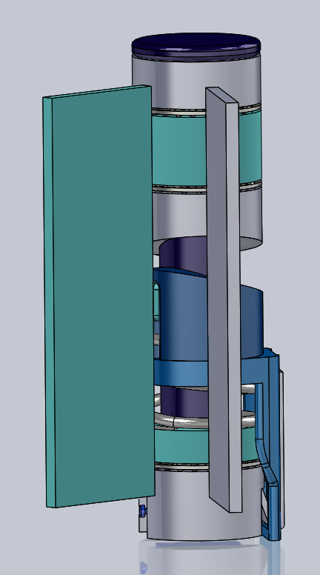 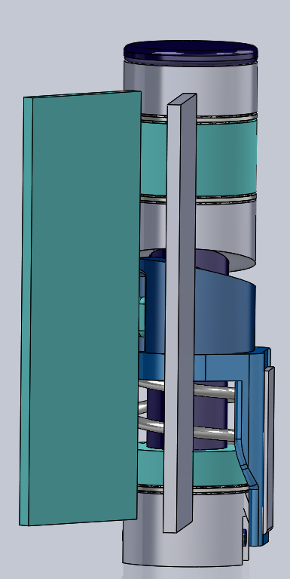 ***Figure 1:*** *Pivot mechanism in normal operation* ***Figure 2****: Pivot mechanism after triggered*

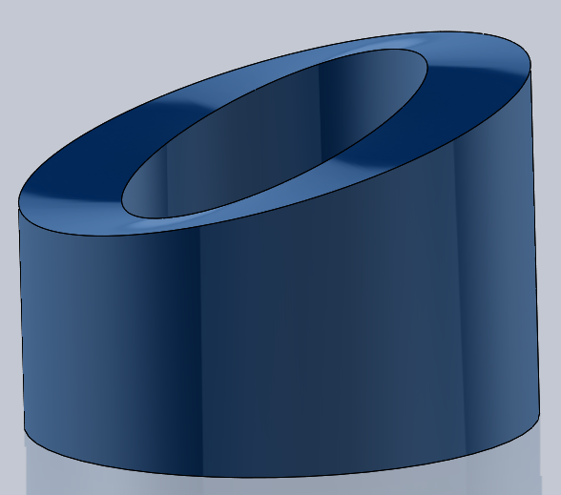 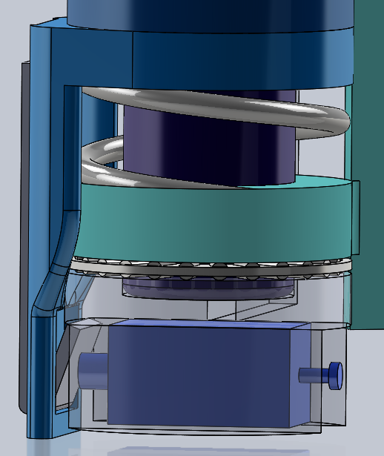

***Figure 3****: Detail view of lower pivot profile*  ***Figure 4:*** *Detail View of Triggering Mechanism*

### Proposed Idea 2 - Compression Screw Mechanism

The compression screw mechanism is shown in Figures 5 and 6. This mechanism consists of two interlocking hinge plates with needle roller thrust bearings at all knuckle contacts. The OD of the mechanism is 1 ¼”, with a ¾” pin. In the center of the hinge the pin is 1”-4 lead screw on which rides a lead nut. The lead nut floats on a cylindrical extrusion from the door side hinge plate. This allows the door free rotation in normal operation. A compression spring with a spring rate of 70 lbs/in, is held in compression between the bottom knuckles of the hinge and the triggering mechanism. The triggering mechanism consist of a ¼” wide 1.25” OD washer that surrounds the lead screw. From this washer extends an 1 ¼” long section that encases a 1/16” wide piece of spring steel that has bent to 20° angle. The end of the spring steel catched onto the underside of the solenoid encasement. When smoke is detected the micro push/pull solenoid hits the bent spring steel and disengages it from the solenoid encasement, which frees the spring. The spring extends, meeting the lead nut with 70 lb/in of spring force. As the lead nut is pushed upwards, it creates torque, causing the door to shut. The door remains spring loaded until the triggering mechanism is once again latched on the solenoid encasement.

***Table 2****: Benefits and Drawbacks for Design 2*

| **Benefits** | **Drawbacks** |
| --- | --- |
| * Utilizes a compression spring instead of a torsion spring, reducing potential axial misalignment * Utilizes a well defined screw profile * Can be reset from any position * Triggering mechanism could be 3D printed * Remains spring loaded until reset | * Potentially complicated machining- must machine down some threads of lead screw stock to create pin and remove material from lead nut * Can not be easily installed by removing pin * 1.25” barrel diameter * Triggering mechanism protrudes slightly from hinge * Loss of knuckles could lead to hinge misalignment |

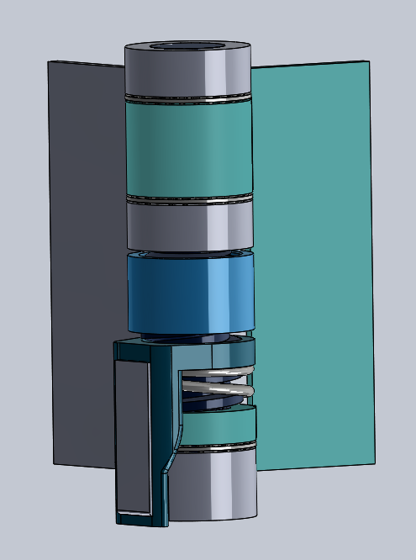 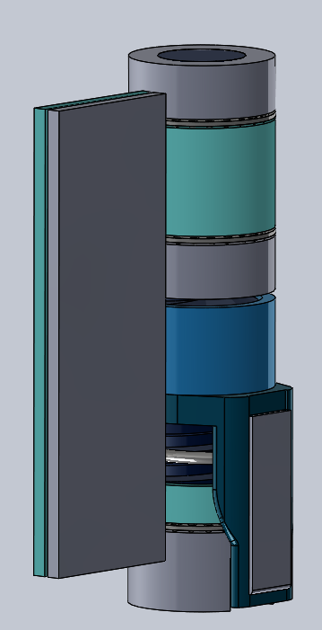 ***Figure 5:*** *Screw mechanism in normal operation* ***Figure 6:*** *Screw mechanism when triggered*

### Proposed Idea 3 - Enclosed Gear

The enclosed gear in Figures 7 and 8 utilizes a gear and an electric motor to close the door. The electric motor is always off until it receives a voltage from the smoke detector. Once the voltage is received the motor is activated, and runs for a couple seconds. This supplies torque onto the threaded gear which is held in place by two nuts, creating a moment on the middle barrel only, closing the door. Once the door is shut, the motor will be shut off freeing the shaft to rotate in either direction allowing the door to be opened without stripping the gears. Assuming that the shaft is only partially threaded, and the coefficient of friction of the material isn’t significant, the bottom unthreaded portion of the shaft should spin freely in the bottom barrel of the hinge. This supplies a large enough moment on the doors axis closing the door.

***Table 3****: Benefits and Drawbacks for Design 3*

| **Benefits** | **Drawbacks** |
| --- | --- |
| * User friendly. * Includes no spring. * Uses a gear which increases reliability * Does not need to be set or reset * Resembles a typical hinge. | * Must program the motor so the door can be opened without stripping the gears * Friction on the bottom of the pin could cause an opposing moment * Needs max barrel diameter (1.25”) * Motor speed has only one setting. |

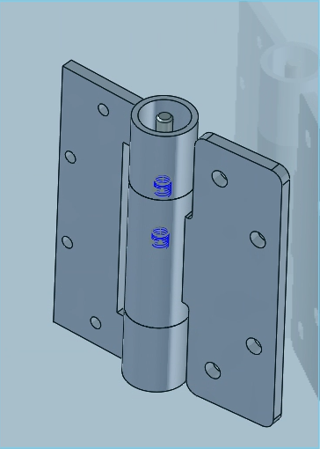 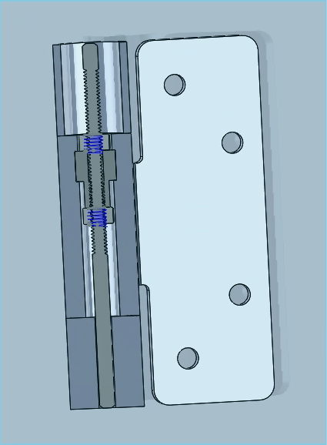

***Figure 7:*** *Full enclosed view of hinge* ***Figure 8:*** *Cutaway view of hinge mechanism*

### Proposed Idea 4 - Perpendicular Ratcheting System

The Perpendicular Ratcheting System, shown inFigures 9 and 10, uses a small but powerful pull actuator with a ratcheting key and gear at the bottom of the hinge to allow for a single way of rotation but hinder the rotation in the counterclockwise direction. The functionality of this design is such that it will be opened the first time to set the mechanism and lock the gear and torsion spring in their desired angle of preload, then the door will act as a free floating door that will then be under its own weight. Once the smoke alarm in a surrounding room of the house is triggered, an input power of 9 volts will be sent to the actuation device and the pull actuator will retract, separating the ratcheting key away from the gear. The preloaded force of the torsion spring will then make contact with the door side of the hinge and apply 70 lbs/in^2 of torque to the door at the hinge, closing the door completely. If the door is then needed to opened while the fire threat is still imminent, the pull actuator will still be given constant power thus allowing the torsion spring to continue applying its torque output to the door to return it to its closed state.

***Table 4****: Benefits and Drawbacks for Design 4*

| **Benefits** | **Drawbacks** |
| --- | --- |
| * Uses low voltage pull actuator * Utilizes a gear to allow for multiple axial rotation hold points to allow for use on multitude of different door opening layouts. * Very easy to do a maintenance check on the ratcheting system to make sure it’ll still work when needed | * Potential for high friction between ratcheting device and gear itself. * Has a 1” by 2” protrusion from the barrel of the hinge which could limit application possibility. * Doesn’t follow the constraints of having the device look like a hinge and fit inside of a barrel |

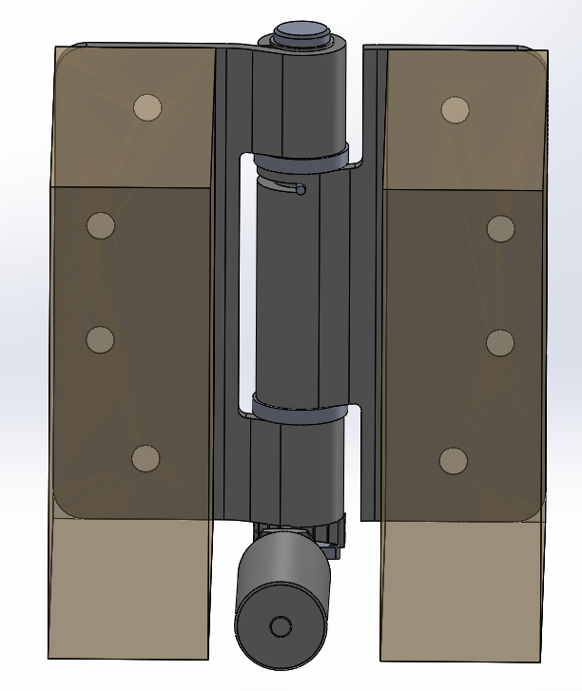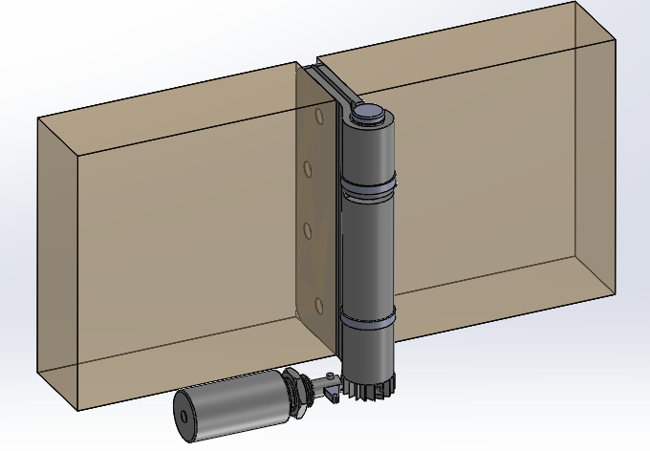

***Figure 9:*** *Opened door view of hinge assembly* ***Figure 10:*** *View of ratcheting mechanism*

### Proposed Idea 5 - Vertical Ratcheting System

The Vertical Ratcheting System shown in Figures 11 and 12 is similar to the Perpendicular Ratcheting System’s design in the fact that it also utilizes a pull actuator with a spring tensioned gear on the bottom edge which applies pressure onto another gear to allow for the ratcheting effect and multiple points of setting, all while holding in the counterclockwise direction but allowing for rotation in the clockwise direction. The functionality of this design is such that it will be opened the first time to set the mechanism and lock the gear and torsion spring in their desired angle of preload, then the door will act as a free floating door that will then be under its own weight. Once the smoke alarm in a surrounding room of the house is triggered, an input power of 9 volts will be sent to the actuation device and the pull actuator will retract, separating the two gear bodys and allowing the preloaded force of the torsion spring to rotate until making contact with the door side of the hinge and apply 70 lbs/in^2 of torque to the door at this point, closing the door completely. If the door is then needed to opened while the fire threat is still imminent, the pull actuator will still be given constant power thus allowing the torsion spring to continue applying its torque output to the door to return it to its closed state.

***Table 5****: Benefits and Drawbacks for Design 5*

| **Benefits** | **Drawbacks** |
| --- | --- |
| * Uses low voltage pull actuator * Utilizes a gear to allow for multiple axial rotation hold points to allow for use on a multitude of different door opening layouts * Entire system is in line with the barrel | * Potential for high friction between the two 3D printed gearbodys * Uses a lower compression spring to continuously hold pressure on the gears which could in turn fail over fatigue * Must find a way to hold actuator in place so it doesn’t slip when activated inside of the barrel. |

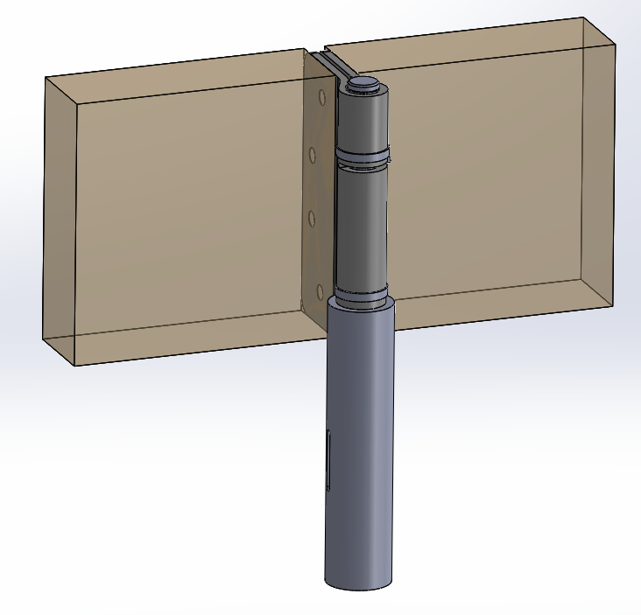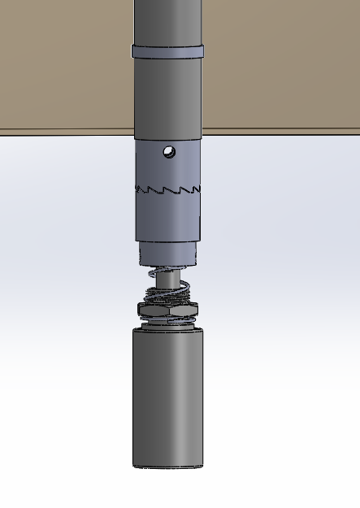

***Figure 11:*** *Complete view of hinge assembly* ***Figure 12:*** *Cutaway view of ratcheting mechanism*

Evaluation Tools

A decision matrix was used to rank the proposed solutions according to key criteria. The most important criteria was effectiveness, followed by ease of resetting, cost and durability. Each design is scored on a scale of 1 to 5, where 1 is the worst and 5 is the best. The scoring guidelines are listed in the Matrix Criteria Breakdown table, below.

Matrix Criteria Breakdown

***Table 6:*** *Matrix Criteria Breakdown Definitions*

| Hinge Appearance (10%) | Priority to minimize footprint and maintain aesthetic appeal:  1 - Does not mimic original hinge design in the slightest  3 - Protrusions from hinge and/or significantly enlarged barrel  5 - Appearance is identical to typical hinge |
| --- | --- |
| Easy Reset (20%) | Required to have an easy way of resetting in case of false alarm for homeowners use:  1 - Ergonomic issues with resetting with hold pins, wedges, etc.  3 - Minimal effort required to reset, minimal interaction  5 - Self resetting and no human interaction needed |
| Cost/Manufacturability (15%) | 1 - $200+  2 - $150-200  3 - $100-150  4 - $50-100  5 - $0-50 |
| Safety (5%) | Safety while installing and resetting hinge:  1 - Pinch points present, resetting with arm in tight space  3 - Possible pinch points, reset using hand with ease  5 - Self resetting and no possible injury to occur |
| Effectiveness/  Reliability (35%) | Activation of mechanism when smoke detector is triggered  Product functions correctly each and every use:  1 - Possible frictional forces unable to overcome  3 - Hinge experiences minor frictional hold ups, operates correctly under entire duration of event  5 - Hinge theoretically works 100% of the time, holds up to conditions |
| Durability (15%) | Product will remain in operating order given intense conditions:  1 - Product is non reusable  3 - Product will not be usable after a few uses  5 - Product can be used throughout life of the door |

The final scores for each design are shown in the decision matrix, below. Each score was multiplied by the criteria’s weight and summed to give a total score. The design with the highest score was designated to be the best/recommended solution.

### Decision Matrix

***Table 7****: Decision matrix for all recommended designs*

|  | Weight | Design 1 | Design 2 | Design 3 | Design 4 | Design 5 |
| --- | --- | --- | --- | --- | --- | --- |
| Hinge Appearance | 10% | 4 | 3 | 3 | 2 | 4 |
| Easily Reset | 20% | 3 | 3 | 5 | 4 | 4 |
| Cost/  Manufacturability | 15% | 4 | 3 | 4 | 3 | 3 |
| Safety | 5% | 5 | 4 | 4 | 3 | 4 |
| Effectiveness | 35% | 4 | 3 | 1 | 3 | 3 |
| Durability | 15% | 5 | 5 | 3 | 4 | 5 |
| **Total Score** | **100%** | **4** | **3.35** | **2.9** | **3.25** | **3.65** |

Work Plan

Smoke Shield has discussed a three-stage plan of completion for the design, testing, and implementation of the smoke activated door hinges. The three-stages consists of research & planning, brainstorming & designing, and prototyping & testing. Research & planning stage will be when we study all existing products, get an understanding of fire codes, look at how fire alarms work, evaluate how other products intercommunicate, and generate a week-to-week plan for completion. Brainstorming & designing incorporates the various routes we can take mechanically to achieve this and than modeling the mechanical solutions in SolidWorks. Prototyping & testing will come after the client has decided the route they want to go with the different design options, after it is decided FEA analysis will be ran on the solidworks part and drawings will be made to manufacture the first prototype. Once the first prototype is generated, we will implement it onto an actual door and watch it in action, testing it at angles from 5 degrees to 185 degrees, see how easy it is to reset/install, and make sure it is reliable.

Schedule

Smoke Shield has been given 16 weeks to complete all three phases of this project. The following is a visual representation of the timeline of completion:

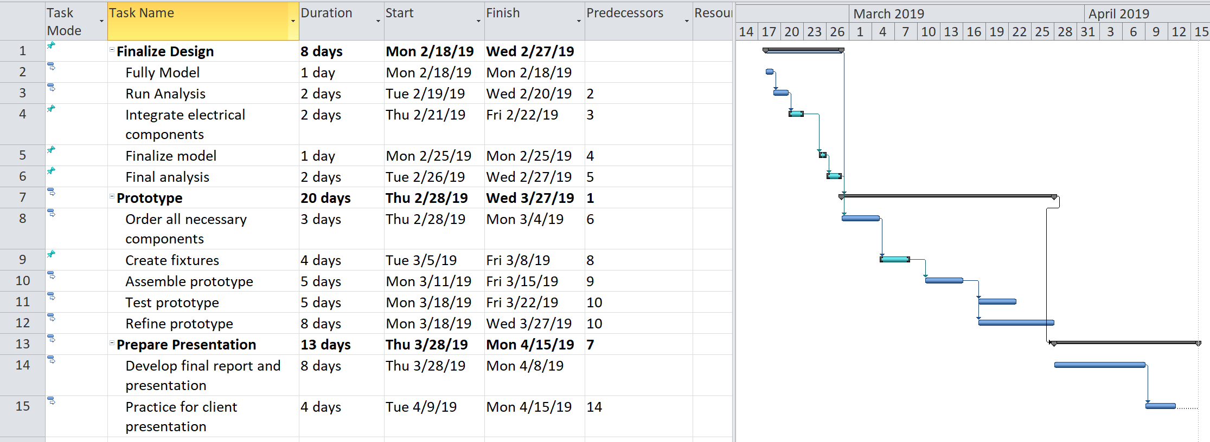

***Figure 13:*** *Project Gantt Chart*

*Phase 1: Preliminary steps before project execution.*

A) Create Team Description and Project Charter by - Tuesday, January 29th.

*Phase II: Design and analysis starting Monday, January 28th .*

A) Brainstorm and model several potential design solutions for the mechanism, hinge design, and release mechanism layout.

B) Present Project Baseline report to client by - Tuesday, February 12th, at the latest.

C) Refine design and perform analytical and computation analysis on critical design parts by - Tuesday, February 26th.

*Phase III: Build system and compile documentation starting March 4th.*

A) Order all necessary components by - Monday, March 4th.

B) Assemble prototype by - Friday March 22nd.

C) Test and analyze system by - Friday, March 29th.

D) Make any necessary design corrections by - Friday April, 5th.

E) Develop final presentation by - Monday, April 15th.

F) Complete project and present to client - April 22nd.

Budget

Smoke Shield was not given an official budget for this project but the goal is to keep the budget cost between 500 and 1,000 dollars. Pricing of parts unique to each design are broken down below. Costs of electrical components are not broken down below, but are expected to be $100-200 for the entire system.

***Table 8:*** *Compression Pivot Budget*

| **Compression Pivot** | | | | |
| --- | --- | --- | --- | --- |
| **Parts:** | **Vendor:** | **Quantity:** | **Unit Cost:** | **Total Cost:** |
| Mini Push Pull Solenoid | Adafruit | 1 ea | $4.95 | $4.95 |
| Compression Spring- 1" Long, 1.225" OD, 1.015" ID | McMaster Carr | 1 ea | $2.87 | $2.87 |
| Needle-Roller Thrust Bearing  for 3/4" Shaft Diameter, 1-1/4" OD | McMaster Carr | 3 ea | $3.30 | $9.90 |
| Zinc-Galvanized Steel Sheet ⅛” thick 12” by 12” | McMaster Carr | 1 ea | $2.60 | $23.39 |
| 1075 Spring Steel Strip 0.0620" Thick, 1/2" Wide, 5 Feet Long | McMaster Carr | 1 ea | $0.83 | $24.73 |
| Dowel Pin  Alloy Steel, 3/4" Diameter, 4" Long | McMaster Carr | 1 ea | $4.63 | $4.63 |
| Low-Carbon Steel Sheet  6" x 6" x 1/4" | McMaster Carr | 1 ea | $9.91 | $19.81 |
| 3D Printed Trigger Mechanism | UMD | 1 ea | $0.00 | $0.00 |
| **Total:** |  | | $29.09 | $90.28 |

***Table 9:*** *Compression Screw Budget*

| **Compression Screw** | | | | |
| --- | --- | --- | --- | --- |
| **Parts:** | **Vendor:** | **Quantity:** | **Unit Cost:** | **Total Cost:** |
| Mini Push Pull Solenoid | Adafruit | 1 ea | $4.95 | $4.95 |
| Compression Spring- 1" Long, 1.225" OD, 1.015" ID | McMaster Carr | 1 ea | $2.87 | $2.87 |
| Needle-Roller Thrust Bearing  for 3/4" Shaft Diameter, 1-1/4" OD | McMaster Carr | 3 ea | $3.30 | $9.90 |
| 1”-4 RH Acme Lead Screw | McMaster Carr | 1 ea | $5.97 | $17.91 |
| 1”-4 RH Lead Nut | McMaster Carr | 1 ea | $6.85 | $6.85 |
| Zinc-Galvanized Steel Sheet ⅛” thick 12” by 12” | McMaster Carr | 1 ea | $2.60 | $23.39 |
| 1075 Spring Steel Strip  0.0620" Thick, 1/2" Wide, 5 Feet Long | McMaster Carr | 1 ea | $0.83 | $24.73 |
| 3D Printed Trigger Mechanism | UMD | 1 ea | $0.00 | $0.00 |
| Low-Carbon Steel Sheet  6" x 6" x 1/4" | McMaster Carr | 1 ea | $6.60 | $19.81 |
| **Total:** |  | | $33.97 | $110.41 |

***Table 10:*** *Gear Mechanism Budget*

| **Gear Mechanism** | | | | |
| --- | --- | --- | --- | --- |
| **Parts:** | **Vendor:** | **Quantity:** | **Unit Cost:** | **Total Cost:** |
| Servo Motor | Amazon | 1 ea | $14.00 | $14.00 |
| 5/16 Nuts - box of 18 | Fleet Farm | 1 ea | $0.78 | $7.00 |
| External Gear | McMaster Carr | 1 ea | $20.79 | $20.79 |
| Zinc-Galvanized Steel Sheet ⅛” thick 12” by 12” | McMaster Carr | 1 ea | $23.39 | $23.39 |
| Medium strength steel threaded rods - class 8.8 3 feet | McMaster Carr | 1 ea | $0.92 | $11.03 |
| **Total:** |  | | $59.88 | $76.21 |

***Table 11:*** *Perpendicular Ratchet Budget*

| **Perpendicular Ratchet System** | | | | |
| --- | --- | --- | --- | --- |
| **Parts:** | **Vendor:** | **Quantity:** | **Unit Cost:** | **Total Cost:** |
| Sealed Linear Solenoids, pull actuator | McMaster Carr | 1 ea | $36.07 | $36.07 |
| Self Closing Hinge | McMaster Carr | 1 ea | $17.33 | $17.33 |
| 3D Print Gear | University of Minnesota Duluth | 1 ea | $0 | $0 |
| Water Jet Ratchet Key | University of Minnesota Duluth | 1 ea | $0 | $0 |
| Steel Sheet  3" x 3" x 3/32" | McMaster Carr | 1 ea | $1.10 | $9.93 |
| 4130 Alloy Steel Round Tubes - 3 ft | Mcmaster Carr | 1 ea | $1.27 | $7.67 |
| 7/16” Steel Rod - 3 ft | McMaster Carr | 1 ea | $1.37 | $8.24 |
| 7/16” OD external retaining ring - box of 50 | McMaster Carr | 1 ea | $0.68 | $6.79 |
| Steel Taper Pin .088” - .11” - box of 50 | McMaster Carr | 1 ea | $0.94 | $11.69 |
| Steel Extension Spring .25” - box of 3 | McMaster Carr | 1 ea | $4.51 | $13.53 |
| **Total:** |  | | $63.27 | $111.07 |

***Table 12:*** *Vertical Ratchet Budget*

| **Vertical Ratchet System** | | | | |
| --- | --- | --- | --- | --- |
| **Parts:** | **Vendor:** | **Quantity:** | **Unit Cost:** | **Total Cost:** |
| Sealed Linear Solenoids, pull actuator | McMaster Carr | 1 ea | $36.07 | $36.07 |
| Self Closing Door Hinge | McMaster Carr | 1 ea | $17.33 | $17.33 |
| 3D Printed Gears | University of Minnesota Duluth | 2 ea | $0 | $0 |
| 4130 Alloy Steel Round Tubes - 3 ft | McMaster Carr | 1 ea | $1.27 | $7.67 |
| 7/16” Steel Rod - 3 ft | McMaster Carr | 1 ea | $1.37 | $8.24 |
| 7/16” OD external retaining ring - box of 10 | McMaster Carr | 1 ea | $0.68 | $6.79 |
| Compression Spring | McMaster Carr | 1 ea | $2.81 | $2.81 |
| Steel Taper Pin .088” - .11” - box of 50 | McMaster Carr | 1 ea | $0.94 | $11.69 |
| **Total:** |  | | $60.47 | $90.60 |

According to the cost analysis above we project that **Design 1 - Compression Pivot**would be the optimal solution and least expensive to manufacture. The cost analysis is only for prototyping, so labor rates are not included in this analysis.

Summary & Recommendation

Cooper Fire Safety aims to create and manufacture a self closing, residential door hinge that will automatically close the door when smoke is detected, lowering cost and the looks from existing products on the market. Cooper Fire Safety has retained the services of Smoke Shield to design, analyze and prototype an effective, self-closing door hinge. The hinge will be resettable by the homeowner, shutting the door to any room when the smoke detector is triggered. In addition to a working prototype, Smoke Shield will deliver drawings, procedural documentation and a complete user manual.

Smoke Shield has assessed five in-hinge door closer designs that meet the constraints given by Cooper Fire Safety. The designs consist of a: Compression Pivot Mechanism, Compression Screw Mechanism, Enclosed Gear, Perpendicular Ratcheting System, and Vertical Ratcheting System. Smoke Shield ranked each design according to how well it fit each criteria, then weighted each criteria according to importance. After this analysis, Smoke Shield recommends moving forward with the Compression Pivot Mechanism. The hinge-like appearance, low cost of manufacturing, ease of installation and resetting, and theoretical effectiveness make this the optimal design to meet the needs of Cooper Fire Safety.

Following this report, Smoke Shield will immediately move forward with the design chosen by Cooper Fire Safety. This will include finalizing the design, constructing and testing the prototype. Following the schedule proposed in this report, Smoke Shield will deliver a working prototype and all other materials by April 22nd, 2019.

## Appendix J: Design Review

Following the baseline presentation we narrowed our designs down to 3 choices and further explored them. We settled on the vertical ratchet design as the option to pursue

### Vertical Ratchet:

Design Overview: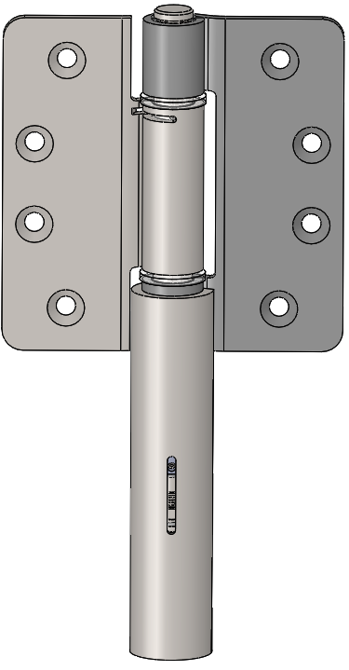

The first time the door is opened the gears ratchet and hold in place at the maximum position, storing the springs torque. When smoke is detected, the solenoid will separate the two gears, releasing the stored spring torsion and closing the doors.

Predicted Points of Failure:

* Gear teeth- will the gear teeth be able to hold force of 40 newtons of force (Analysis ran- Passed)
* Gear friction- will there be enough force provided from the pull actuator to overcome friction created by the opposing gear teeth.
* Spring force- Is there enough spring force to keep the gear teeth in contact while ratcheting and holding.
* Bottom gear vertical track pin - as long as the shear force and or bending moment is significantly large in this material this shouldn’t be an issue to snapping or bending.

Manufacturing:

Custom Gears- Stereolithography (SLA) Manufacturing

SLA Accura Bluestone

* Xometry- $104.00

Benefits:

* Ability to close the door from any angle
* Mechanism is reset by opening the door
* Potential to be very reliable as ratcheting systems have been around for years
* Uses an existing spring loaded hinge
* Maintaining spring tension adjustability in hinge

Concerns:

* Ease of retrofitting to work with existing spring loaded hinge
* Solenoid selection
* Can solenoid overcome the spring force and hold gears apart
* Will gear teeth hold up to ratcheting and holding of device

### Compression Pivot:

Design Overview: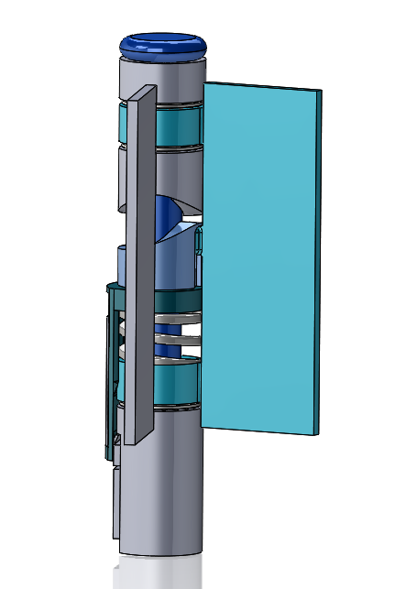

When triggered the compression spring is released and pushes the floating lower pivot into contact with the upper fixed pivot, causing the door to rotate closed.

Recent Changes:

* Changed pivot profile to increase force when door is cracked open
* Reduced OD by 0.25”, to 1”
* Shortened spring trigger and reoriented solenoid
* Changed to a die spring with 550 lb/in of spring force (max force of 220 lb/in)

Predicted Points of Failure:

* Triggering mechanism- solenoid with 80 g of force can’t disengage spring trigger (see analysis)
* Pivot extrusion- small extrusion responsible for transmitting all the torque needed to close the door has max stress over UTS (see analysis)

Manufacturing:

7 custom parts, many could be assembled from purchased components with some modifications

Benefits:

* Removable pin
* Leaves space for electrical components

Concerns:

* Reworked pivot profile increases pitch when door is almost shut, but is fairly flat when door is wide open- may not initiate close
* Effectively closing the door from any angle still a concern (unproven)
* Reopening door and resetting hinge with a spring force of 550 lb/in could require a special tool

### Compression Screw:

Design Overview: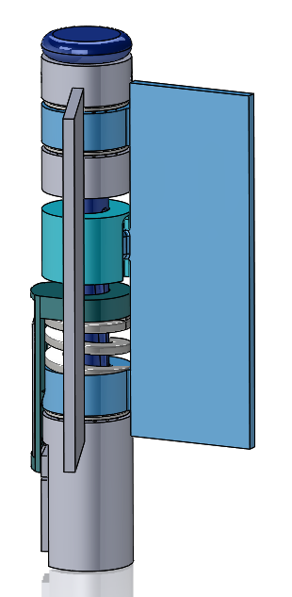

When triggered the compression spring is released and pushes the floating lead nut up, rotating the door shut as the ball lead nut follows the lead screw path.

Recent Changes:

* Switched from lead screw stock to custom threaded pin, with three starts and a multi-pitch ball screw profile to more reliably close a cracked open door
* Reduced OD by 0.25”, to 1”
* Shortened spring trigger and reoriented solenoid
* Changed to a die spring with 550 lb/in of spring force (max force of 220 lb/in)

Predicted Points of Failure:

* Triggering mechanism- solenoid with 80 g of force can’t disengage spring trigger
* Pivot extrusion- small extrusion responsible for transmitting all the torque needed to close the door has max stress over UTS

Manufacturing:

7 custom components, including custom threaded lead screw and ball lead nut.

Benefits:

* New thread profile has sharper pitch when door is nearly closed
* Uses balls in lead nut to run more smoothly
* Leaves space for electrical components

Concerns:

* Reopening door and resetting hinge with a spring force of 550 lb/in